**GIT**

**GIT**

Git is a Distributed Version Control System (DVCS) used to track changes in code, collaborate with teams, and maintain project history.

It helps you:

Track changes

Restore previous versions

Work with branches

Merge features

Collaborate safely

**How to push git to github :**

1. Create a GitHub Repository

2. Go to GitHub → New Repository  
3. Give a name  
4.Click Create Repository

GitHub will show something like:

https://github.com/username/repo-name.git

Copy this URL.

2. Open your project folder in VS Code

Make sure you are *inside the correct folder*.

3. Initialize Git in your project

Open terminal in VS Code:

git init

4. Add your files

git add .

5. Commit your changes

git commit -m "First commit"

6. Add GitHub remote

Paste your GitHub repo link:

git remote add origin https://github.com/username/repo-name.git

7. Push to GitHub

git push -u origin main

git branch -M main

git push -u origin main

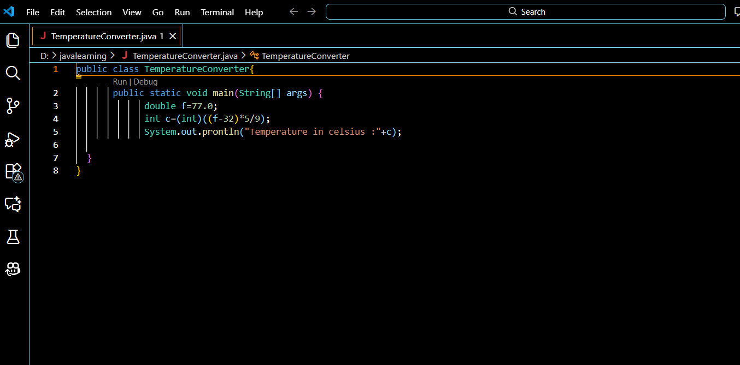

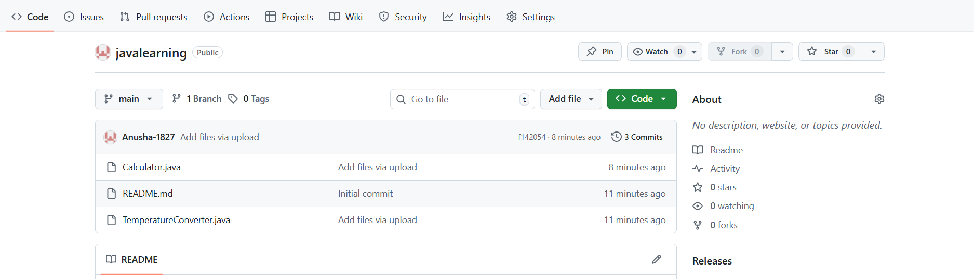

**How to raise pull Requests :**

To raise a Pull Request (PR), first push your changes from your local machine to a new branch on GitHub. After pushing, go to your repository on GitHub and you will see a banner that says “Compare & pull request.” Click on it. Then, review the changes, add a meaningful title and description explaining what you updated or fixed, and make sure the target branch (usually main or master) is correct. Once everything looks good, click “Create Pull Request.” Your PR is now raised, and others can review, comment, or merge it.

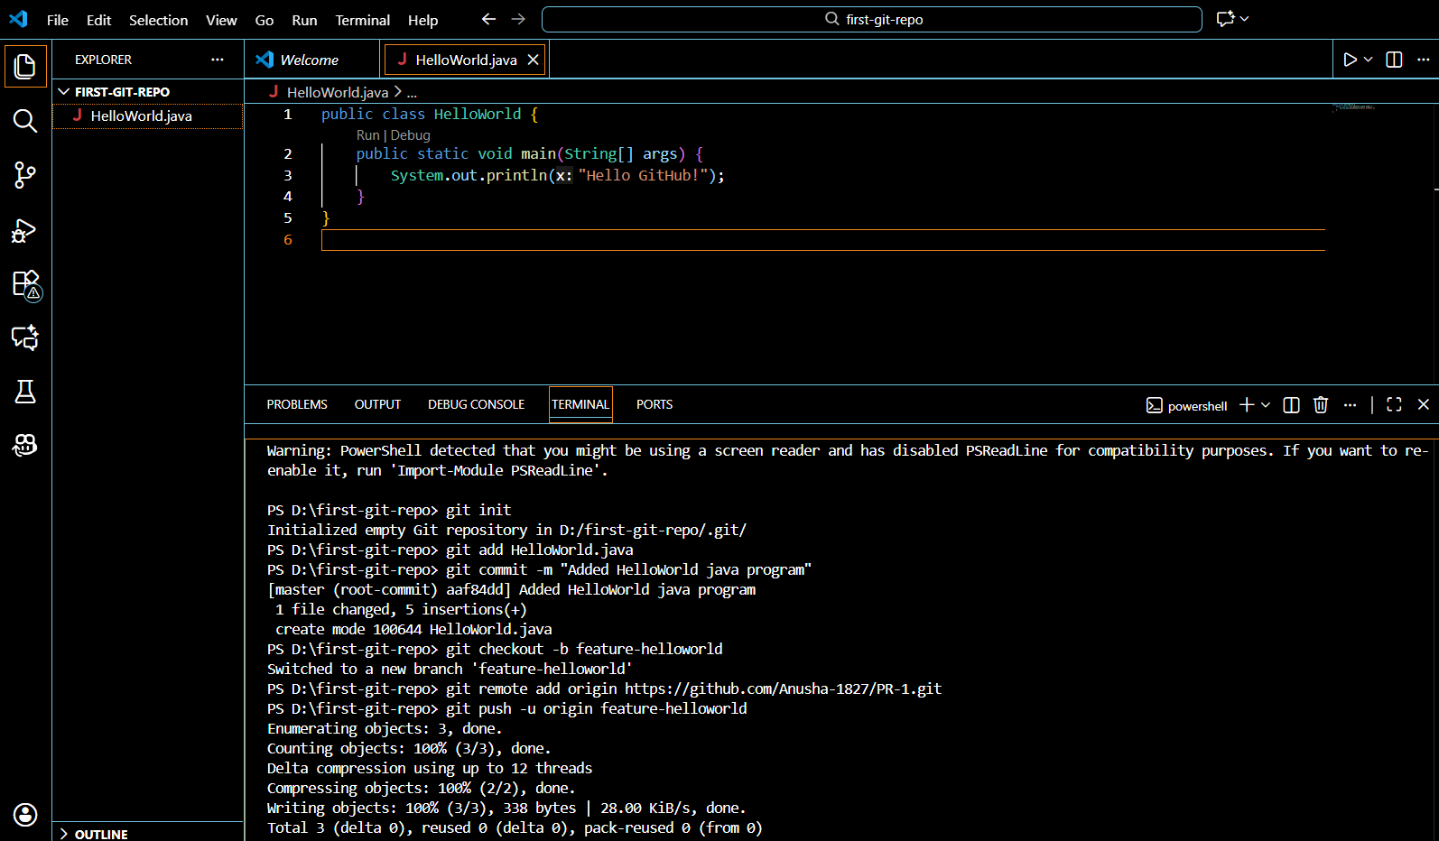

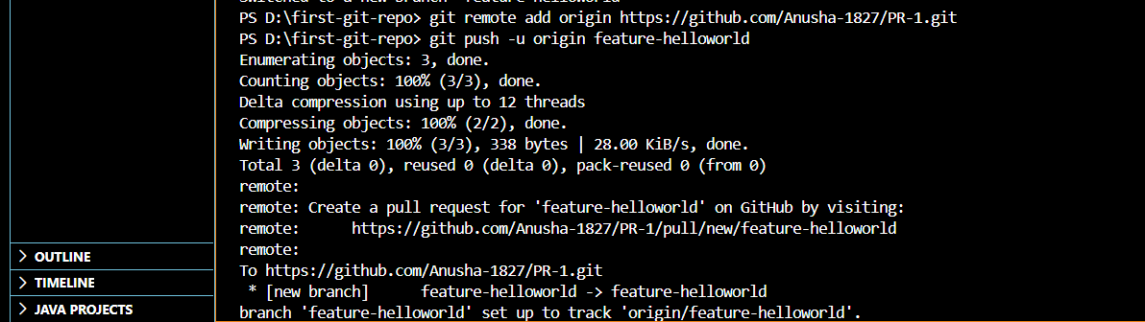

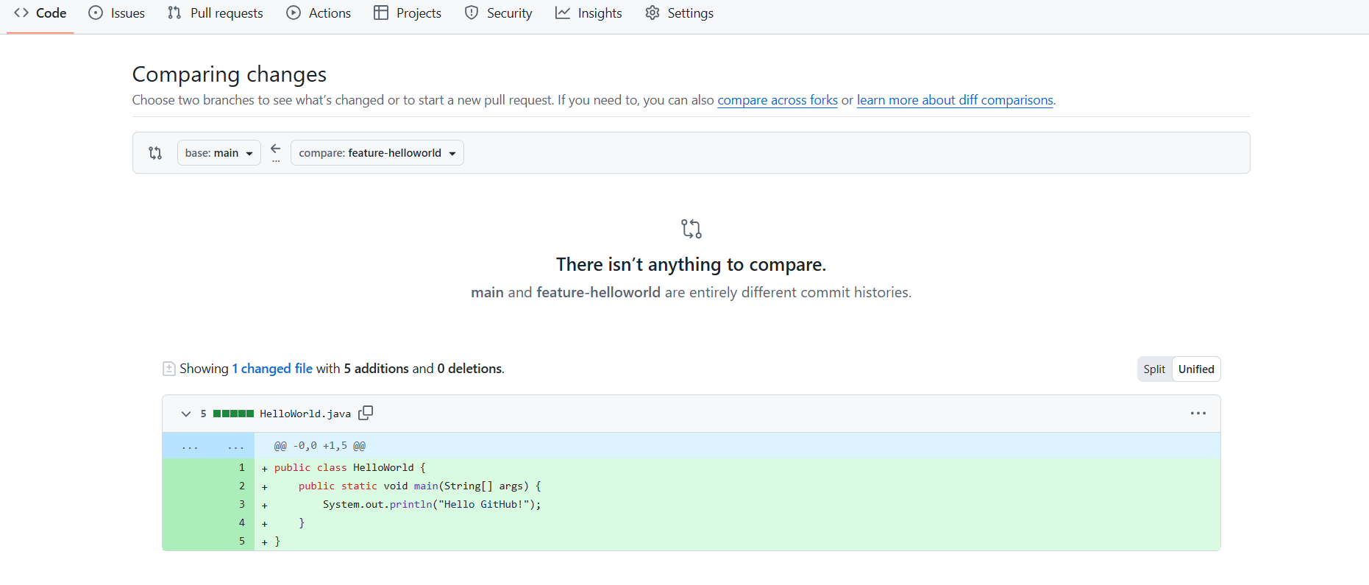

**Git basic commands :**

# git init - Create a new local repository



# git config --global user.name "Your Name" - sets ur global git username

git config --global user.email "[your@email.com](mailto:your@email.com)"- sets your global email

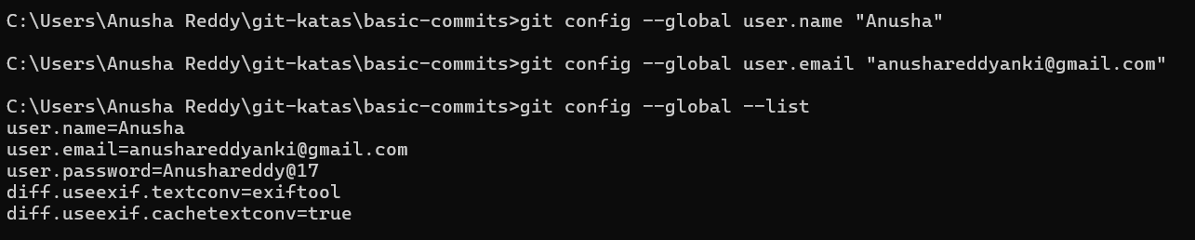

git status - shows changes (modified,untracked,staged)

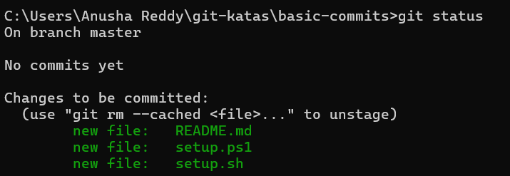

git add - move changes to staging area

Create a file : echo Hello Git > hello.txt

Add and commit a file - git add files and tells what changes u want to save

Git commit - permanently save the changes that were added by git add

Git add . - this moves files to special area called staging area

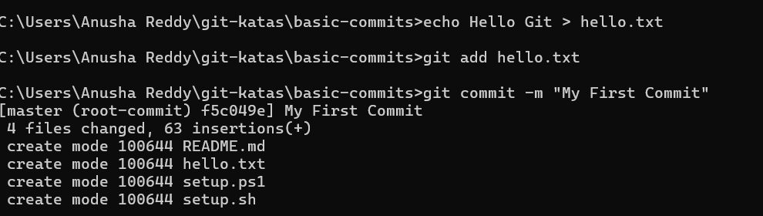

Git revert HEAD This creates a commit that reverts the replacement

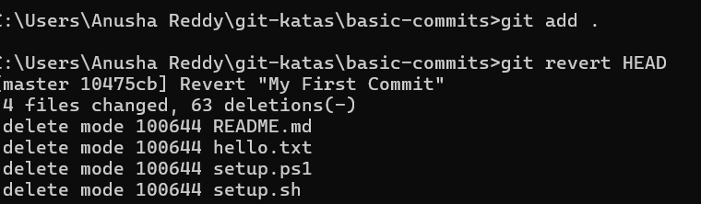

Create a new branch new_branch : -git checkout -b new_branch

git log - shows the history

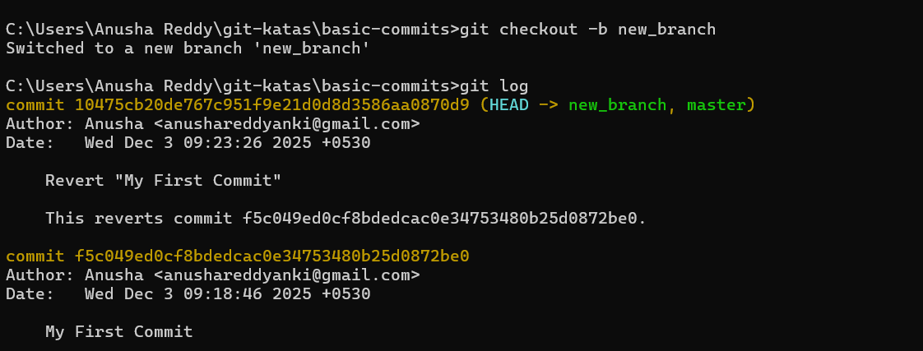

Git diff - difference in working directory

Git diff –staged - difference between stages and last commit

Create a branch -git branch my_branch

Switch branch - git switch mybranch

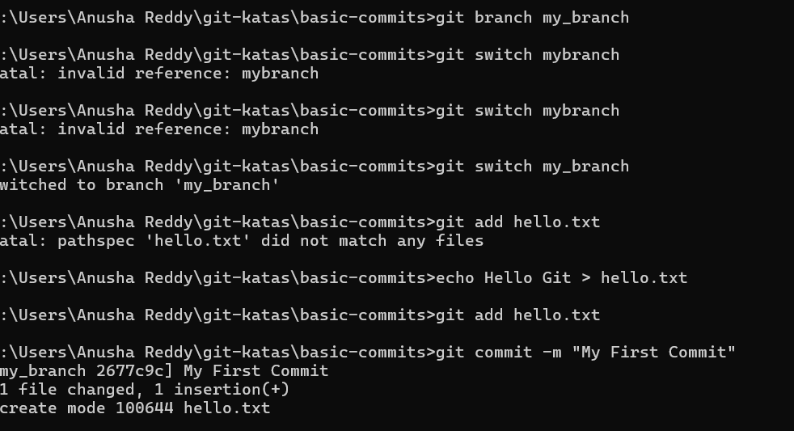

git restore — Undo file changes safely

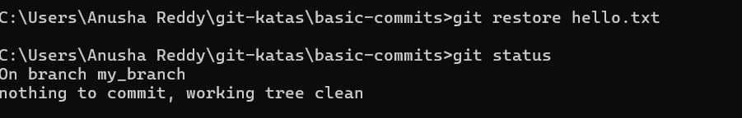

Amend - modify latest commit

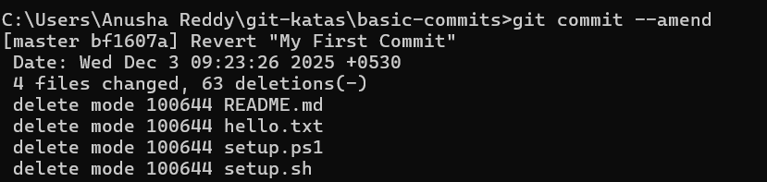

Reset - move header pointer backward

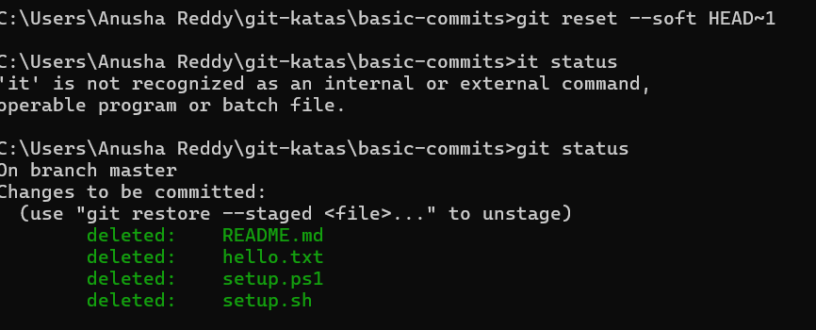

Git reset –mixed HEAD~1 move head back unstage changes

Git log –oneline –graph –all

—> to check the current state

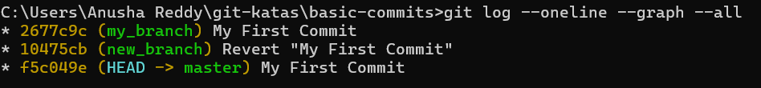

Git switch -c feature - this command is used for switching to a new branch

Git restore — staged file –to unstage

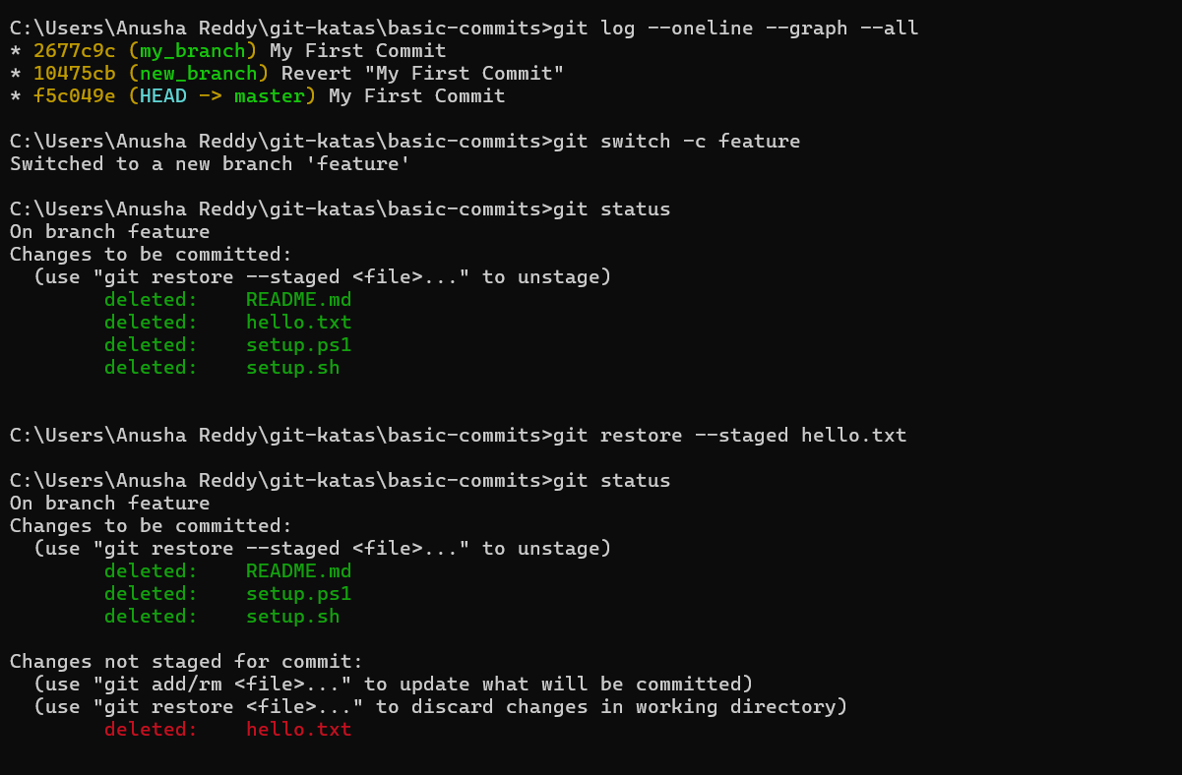

git switch -c greeting –This **creates a new branch** named greeting AND switches to it.

git add greeting.txt -This moves the file greeting.txt into the staging area.

git commit -m "hello" - This creates a commit with the changes you staged.

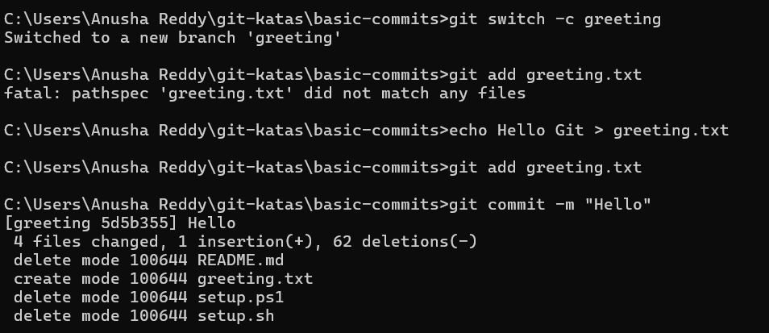

Switch to the master branch.

You must be on the branch where you want to merge INTO.

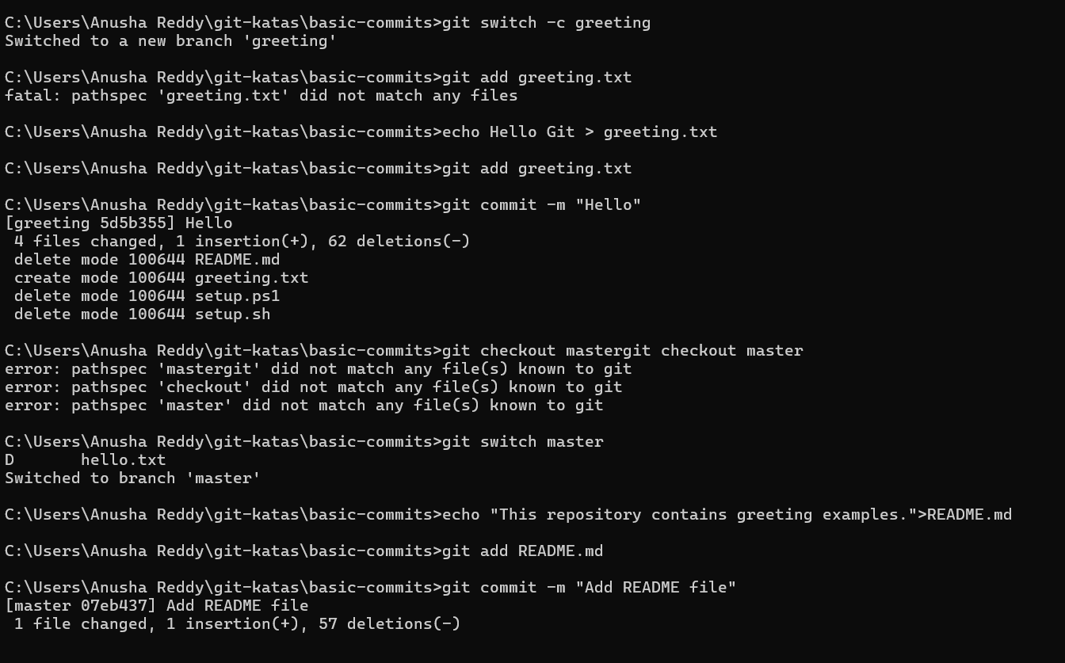

Rebase :

git rebase is used to rewrite commit history by moving your commits to the top of another branch’s latest commits.

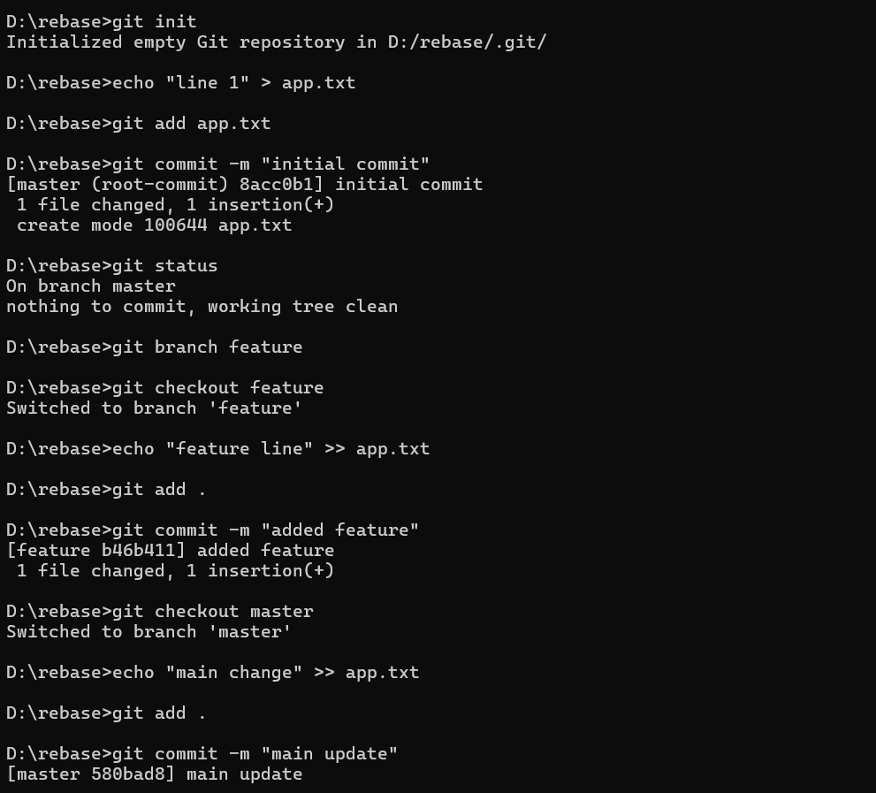

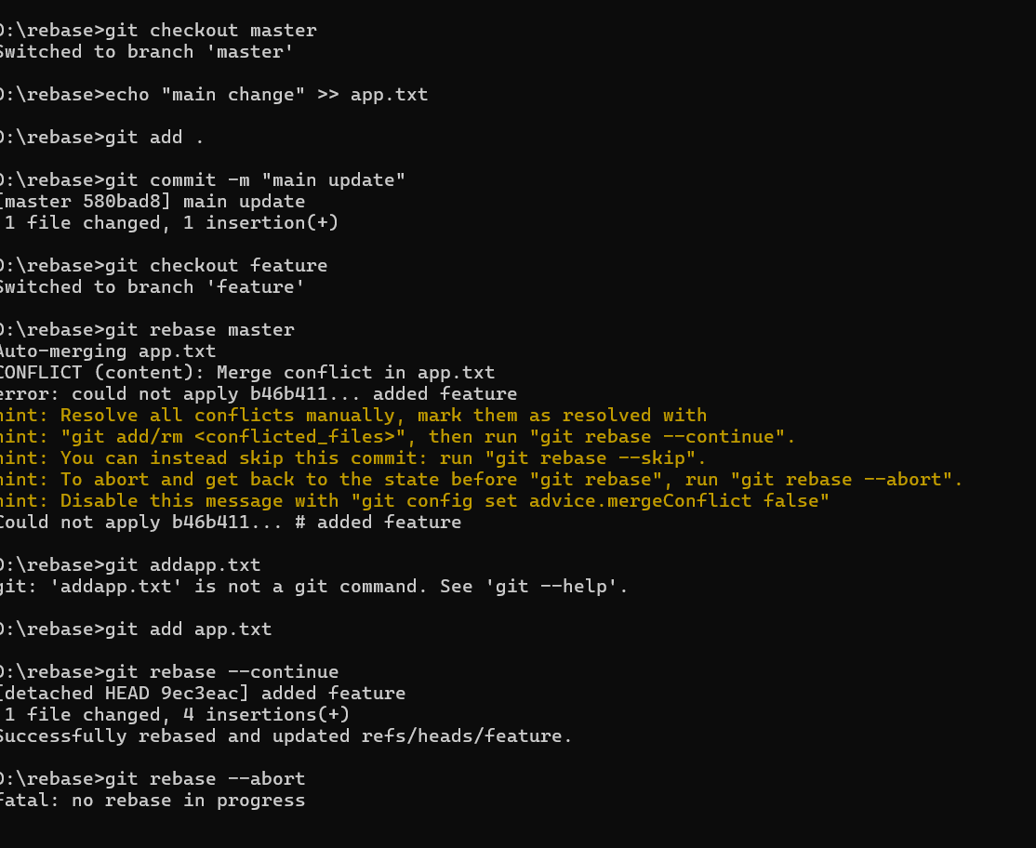

Git revert : git revert creates a new commit that cancels the changes made by an earlier commit.

### 

Git reset : git reset is used to move your HEAD and branch pointer backward to an older commit.

## 1. git status

Shows the current state of your repository:

* changed files
* staged files
* untracked files

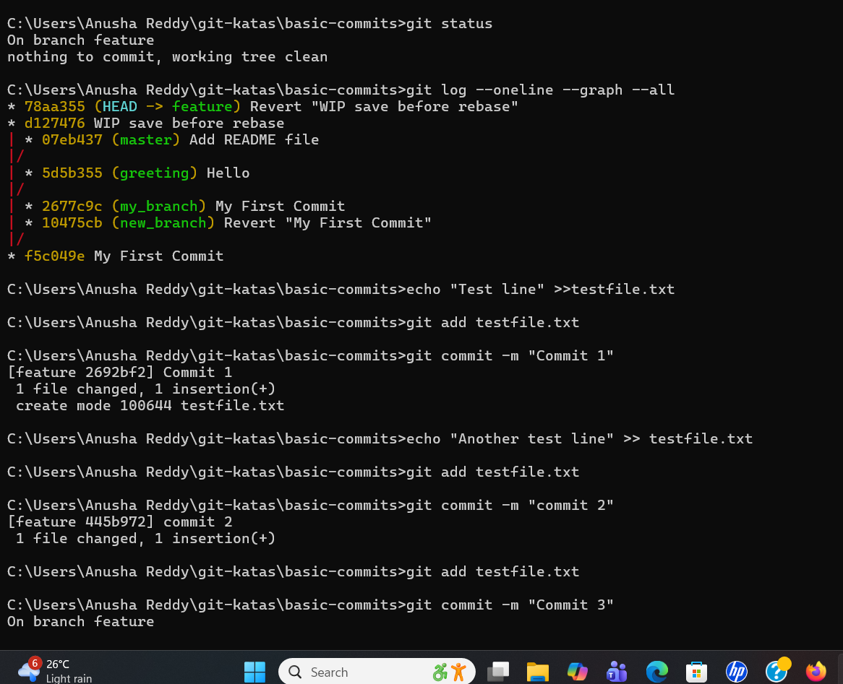

git clean -n →Show which untracked files Git would delete

git clean -n -d→Preview removal of untracked files AND untracked directories.

git clean -f -d→Actually delete untracked files AND untracked directories.

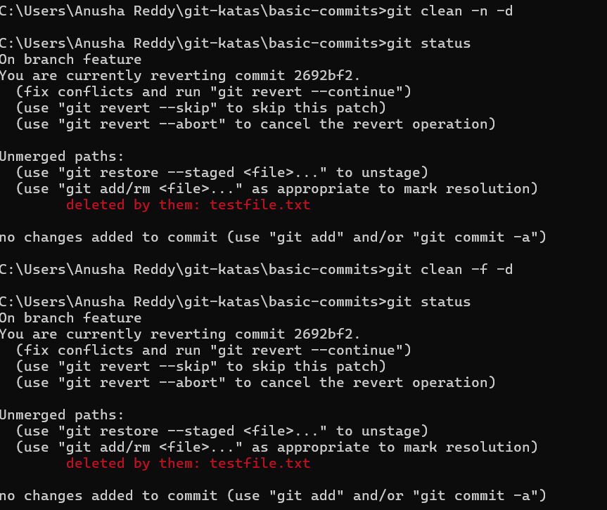

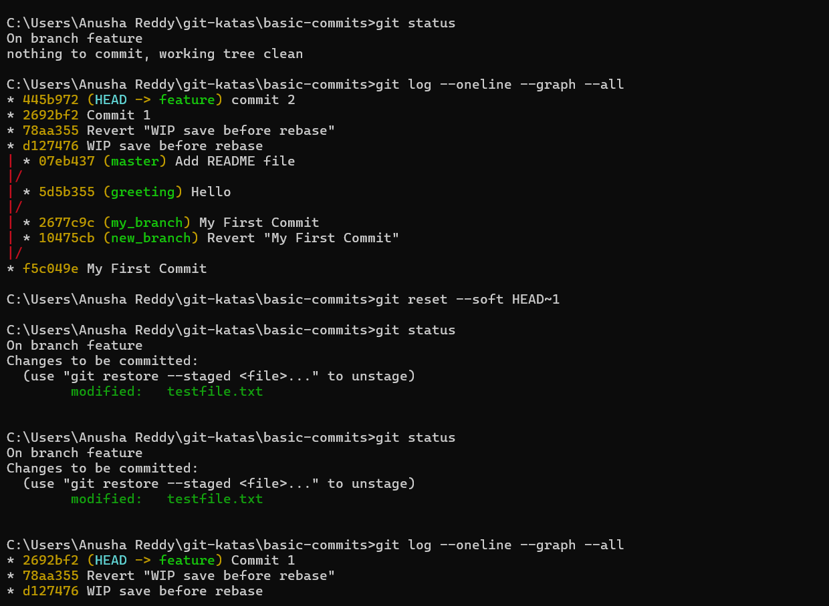

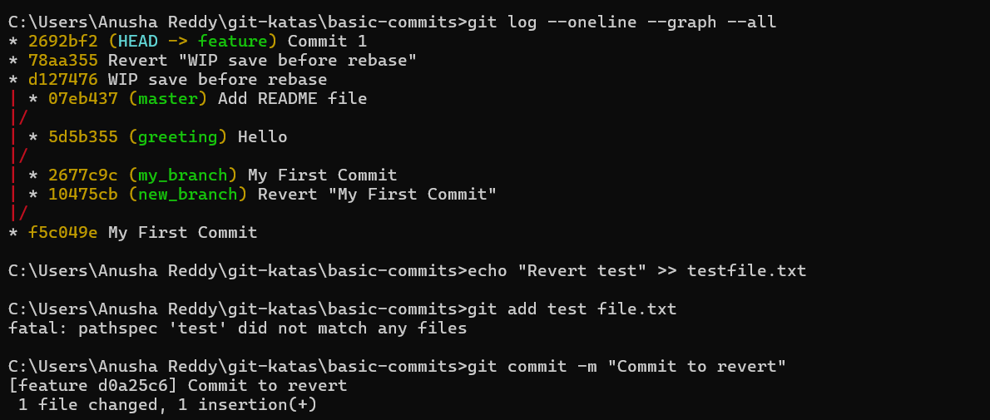

**Merge :** merge is the process of combining the changes from one branch to another branch

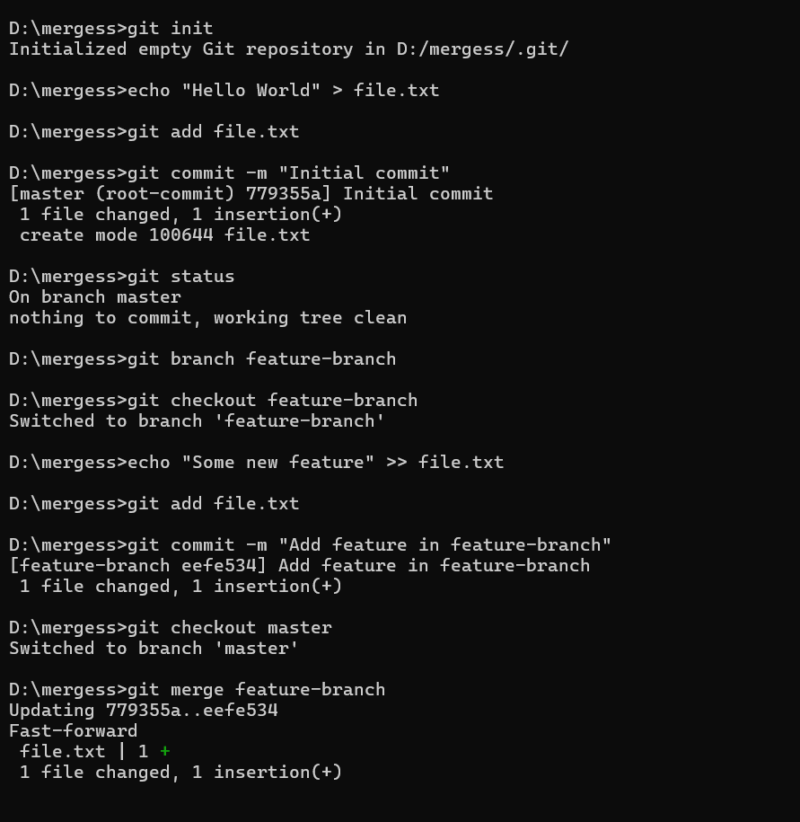

**Merge conflict :** A merge conflict happens in git when two branches change the same part of the same file

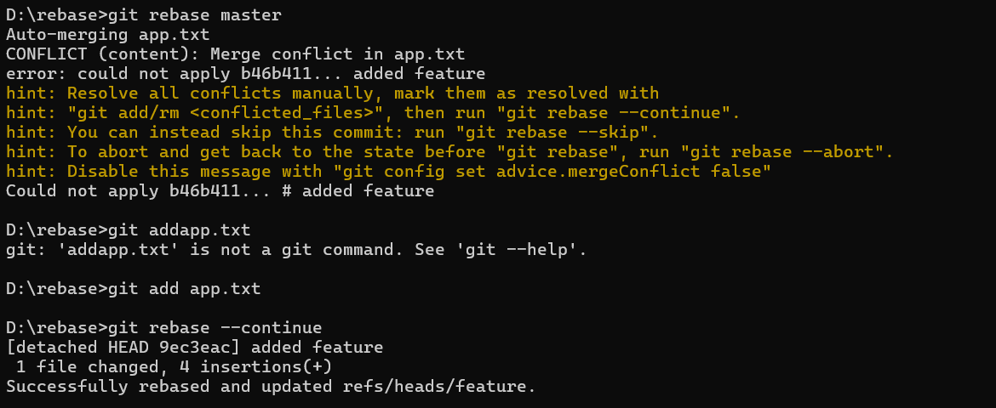

**GIT KATAS**

Katas are hands-on practice exercises designed to help you learn Git by doing.  
 They are similar to coding katas, which are small exercises programmers use to improve their skills.Git

Git Katas are usually short tasks like:

Create a repository

Make commits

Fix mistakes

Merge branches

Resolve conflicts

Use reset, rebase, cherry-pick

Explore Git internals

**BASIC-COMMITS:**

This kata will introduce you to the git add and git commit commands.

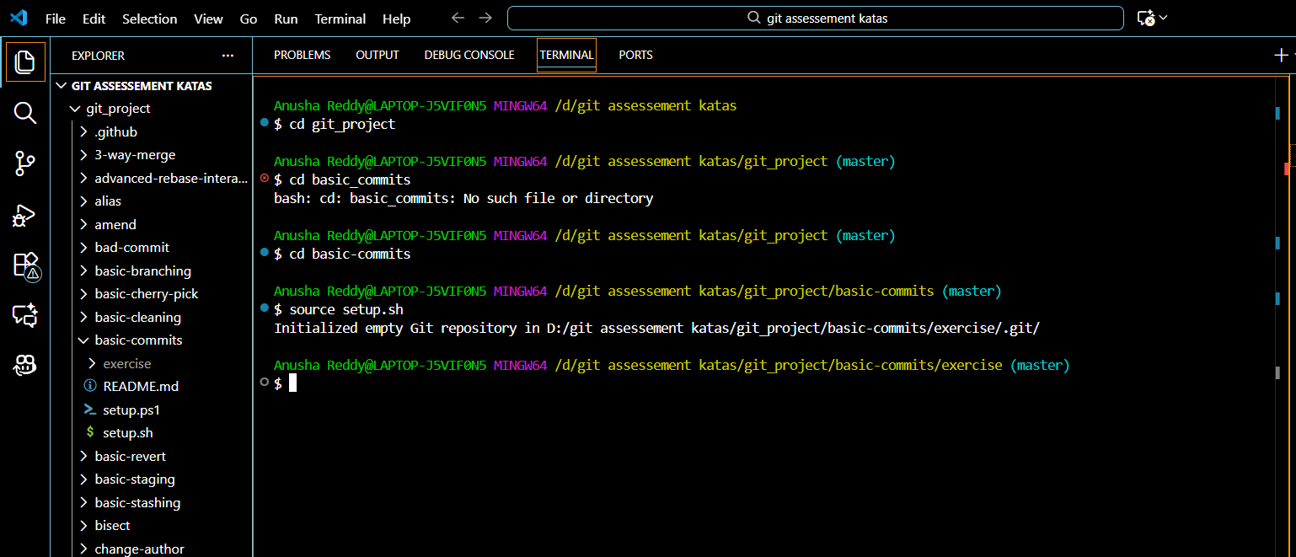

SETUP

Source [setup.sh](http://setup.sh)

Commands for the tasks:

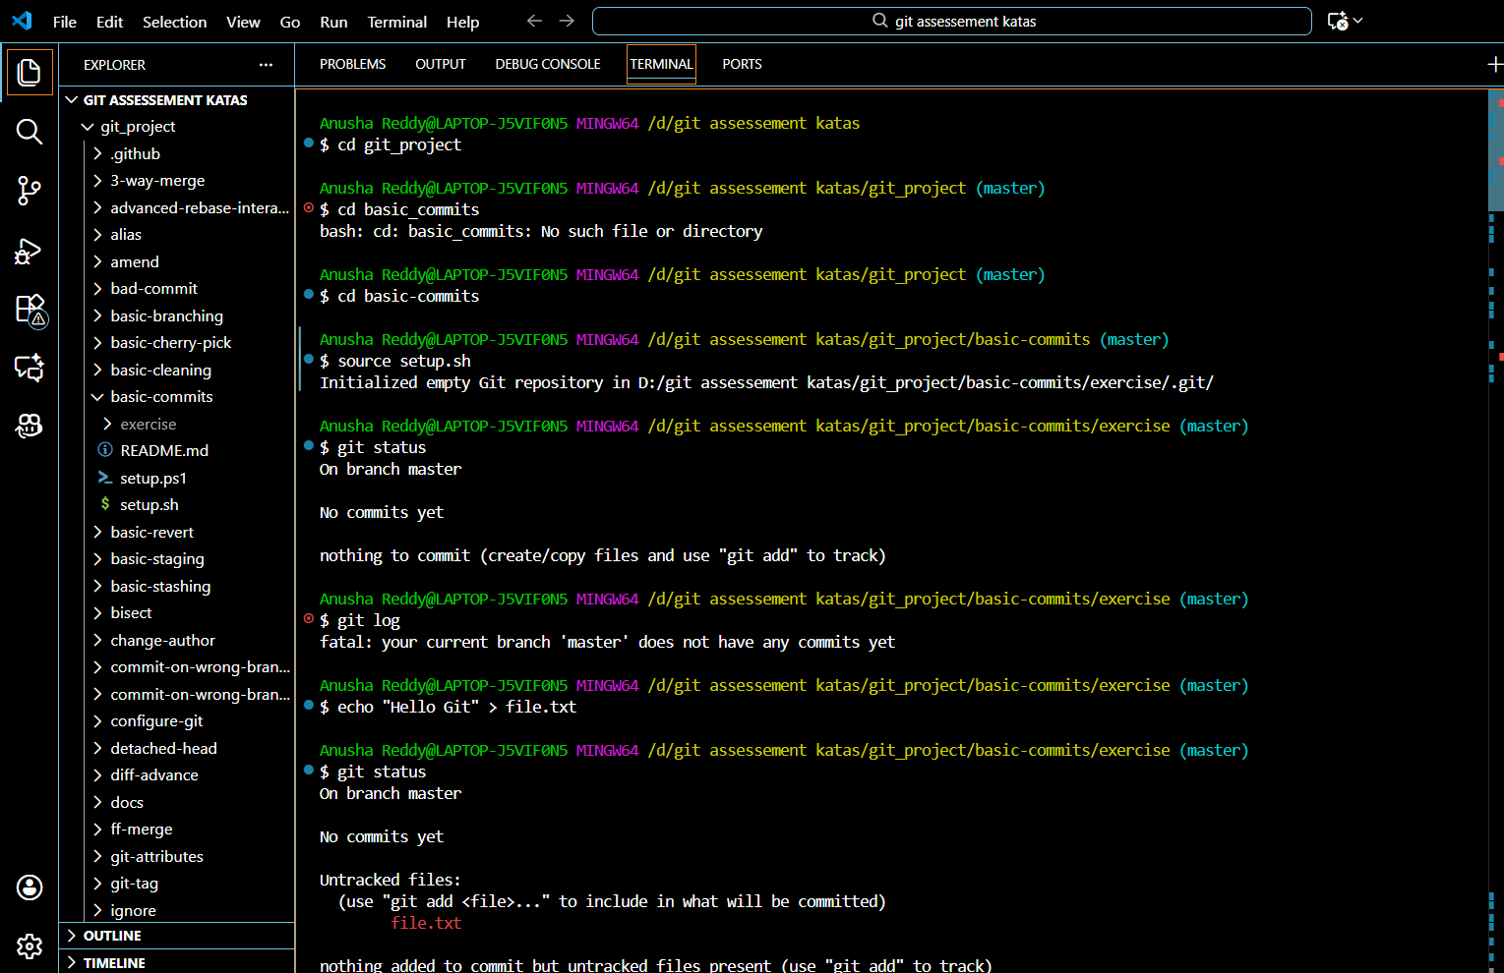

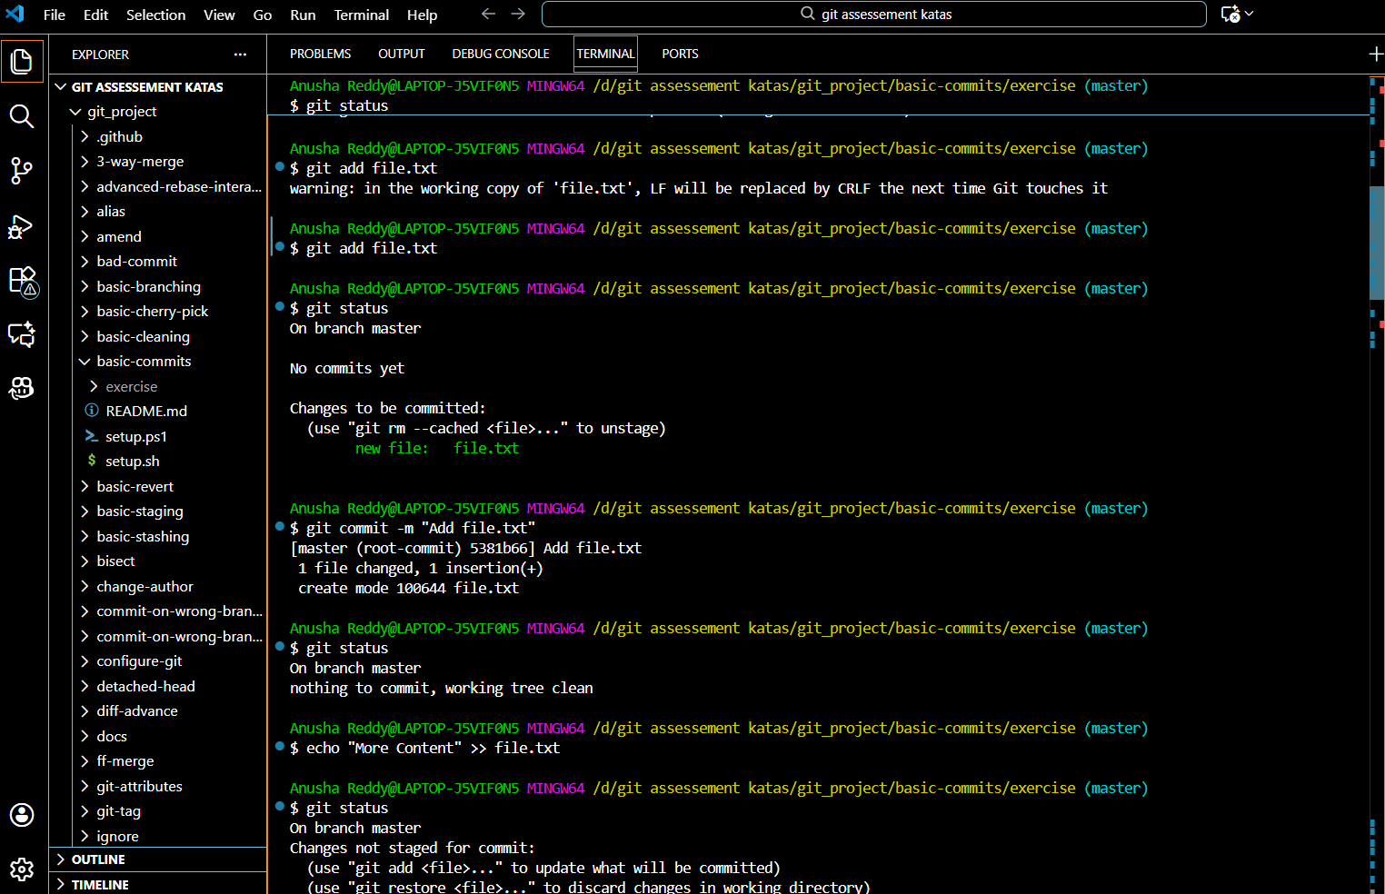

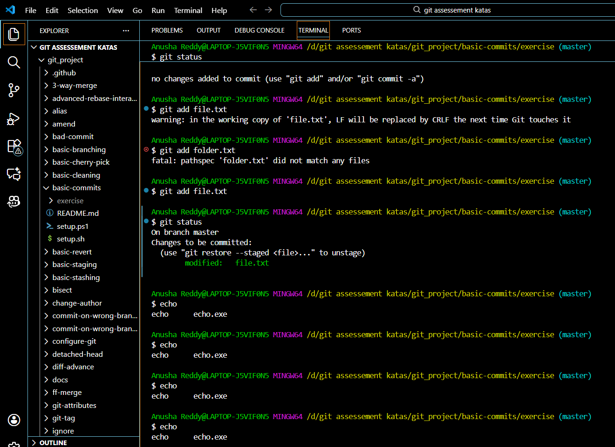

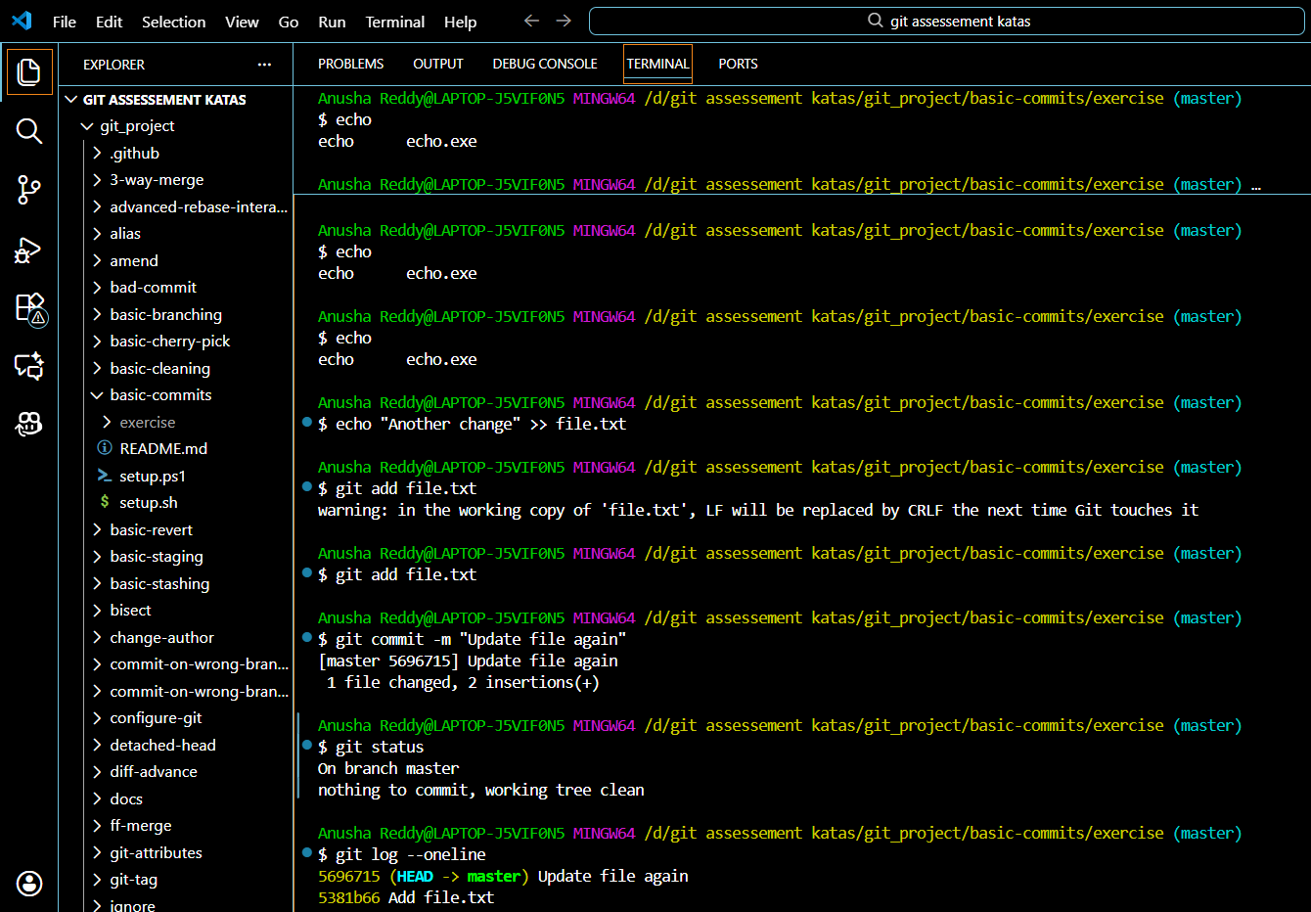

The commands we have used for all the task for the basic commit is

git status

git log

echo "Hello Git" > file.txt

git status

git add file.txt

git status

git commit -m "Add file.txt"

git status

echo "More content" >> file.txt

git status

git add file.txt

git status

echo "Another change" >> file.txt

git add file.txt

git commit -m "Update file again"

git status

git log --oneline

**BASIC-STAGING:**

This kata will examine the staging area of git.

In git we are working with three different areas:

* The working directory where you are making your changes
* The staging area where all changes you have added through git add will stay
* The repository where every commit ends up, making your history. To put your staged changes in here you issue the git commit command.

A file can have changes both in the working directory and staging area at the same time. These changes do not have to be the same.

SETUP

Source [setup.sh](http://setup.sh)

The implementation:

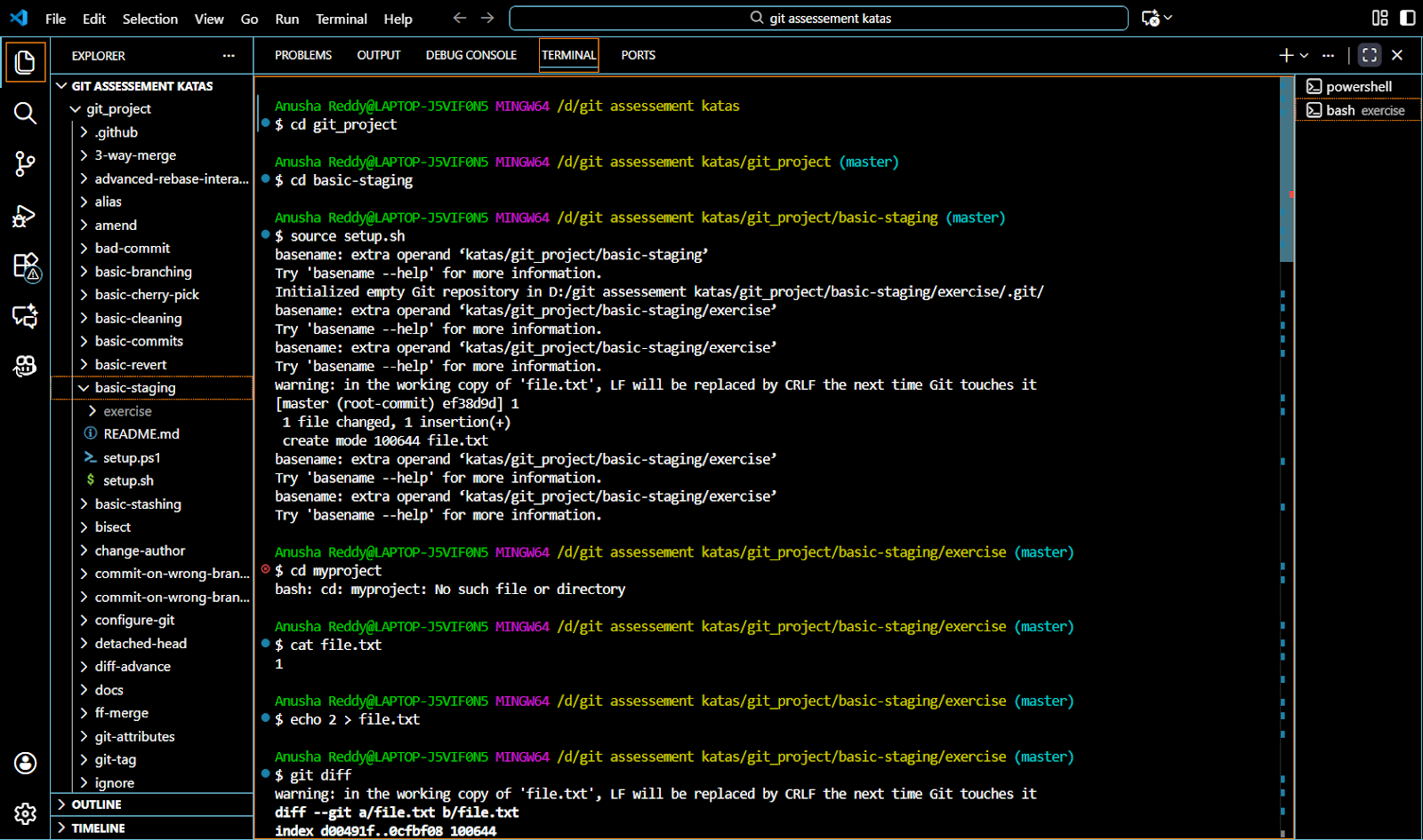

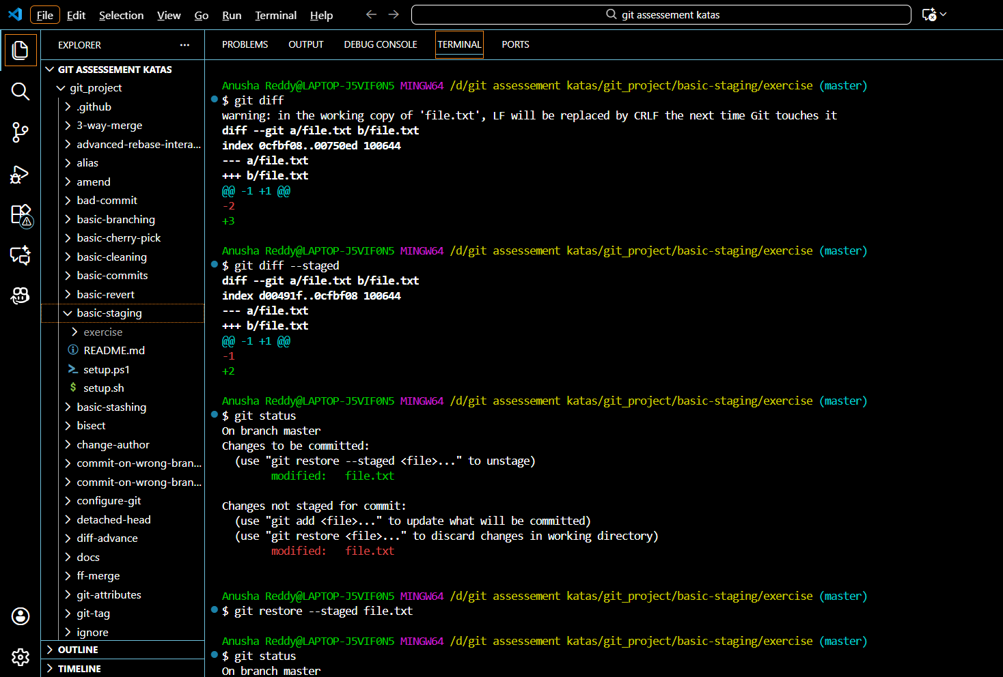

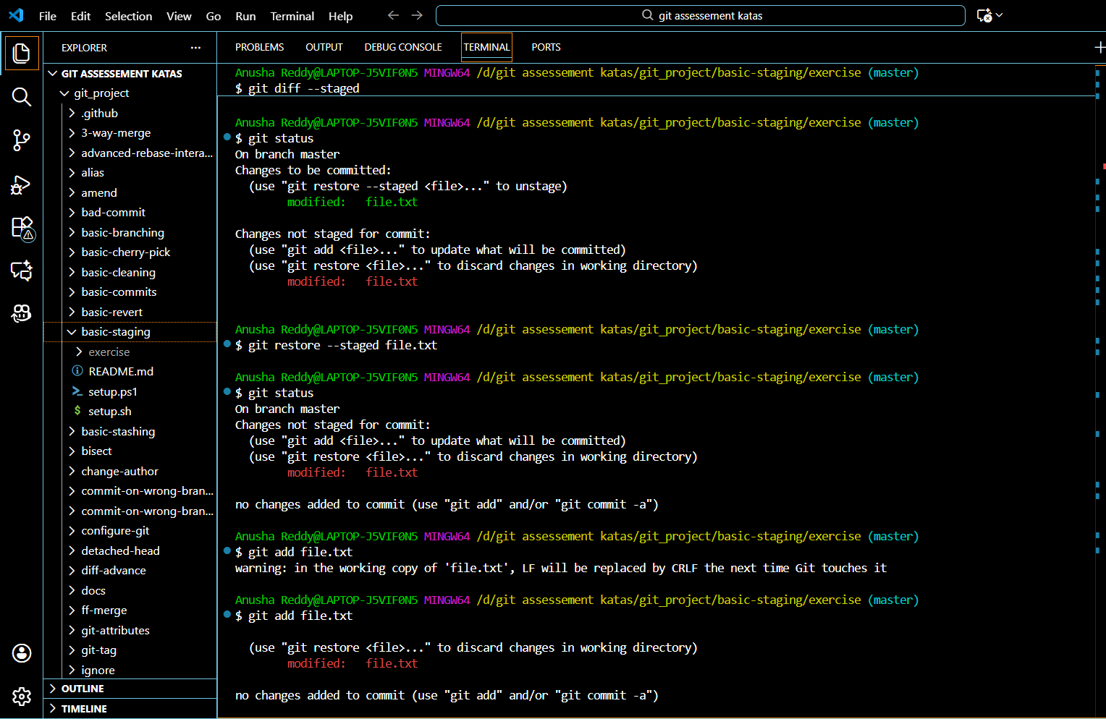

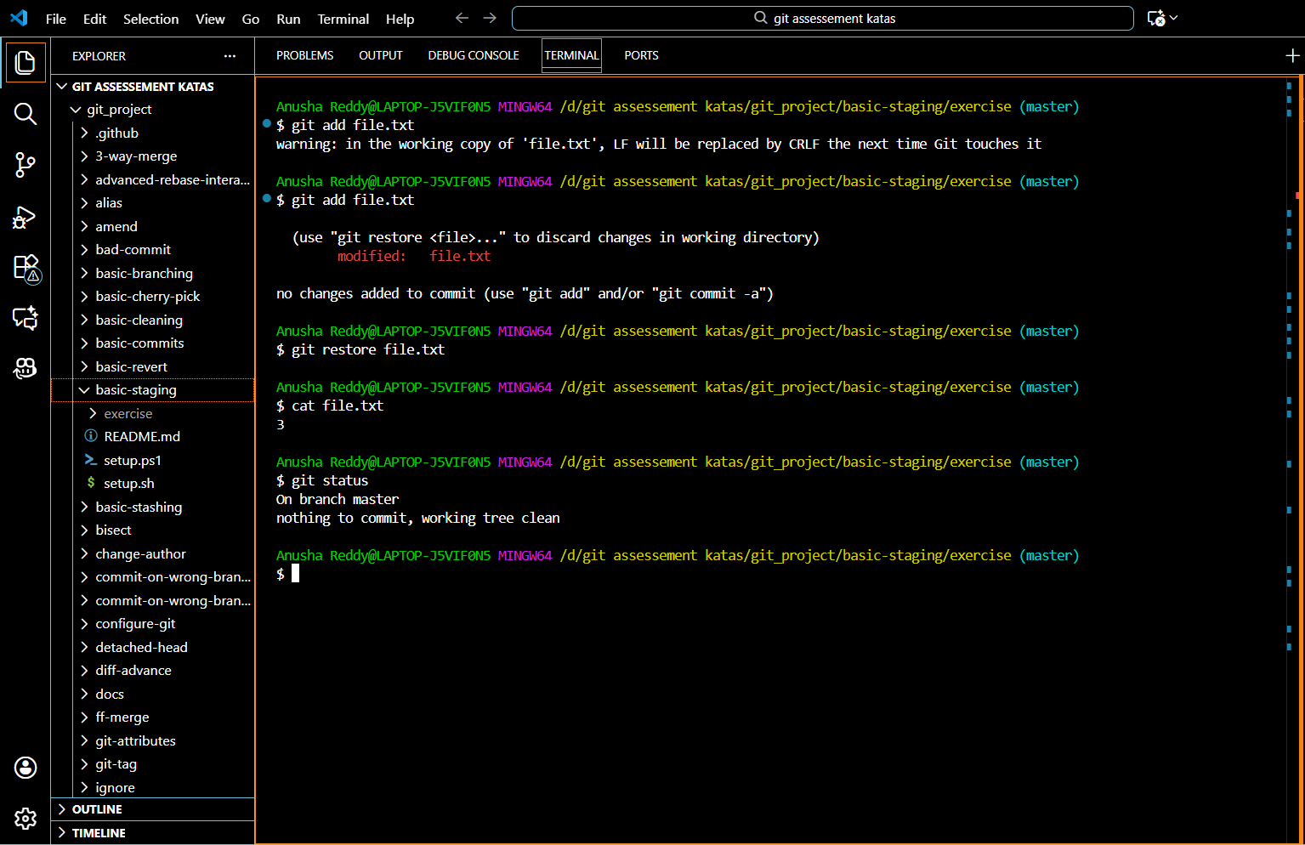

The solutions or commands used for the task:

cat file.txt

echo 2 > file.txt

git diff

git diff --staged

git add file.txt

git diff

git diff --staged

echo 3 > file.txt

git diff

git diff --staged

git status

git restore --staged file.txt

git status

git add file.txt

git commit -m "Update file.txt to 3"

git log --oneline

echo 4 > file.txt

cat file.txt

git status

git restore file.txt

cat file.txt

git status

**BASIC BRANCHING :**

The Basic Branching Kata is a Git practice exercise designed to teach you:

### How to create branches

### How to switch between branches

### How to make commits in different branches

### How to merge branches back into main

### How changes differ across branches

SETUP

Source [setup.sh](http://setup.sh)

The implementation:

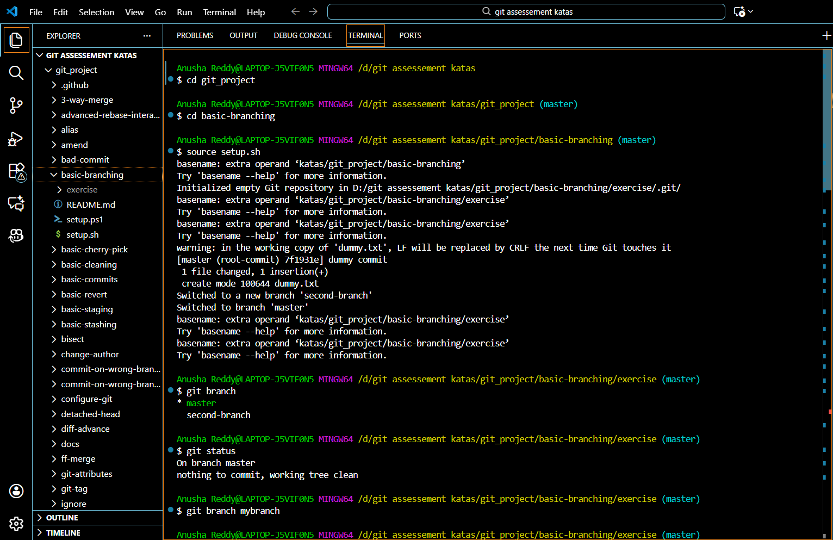

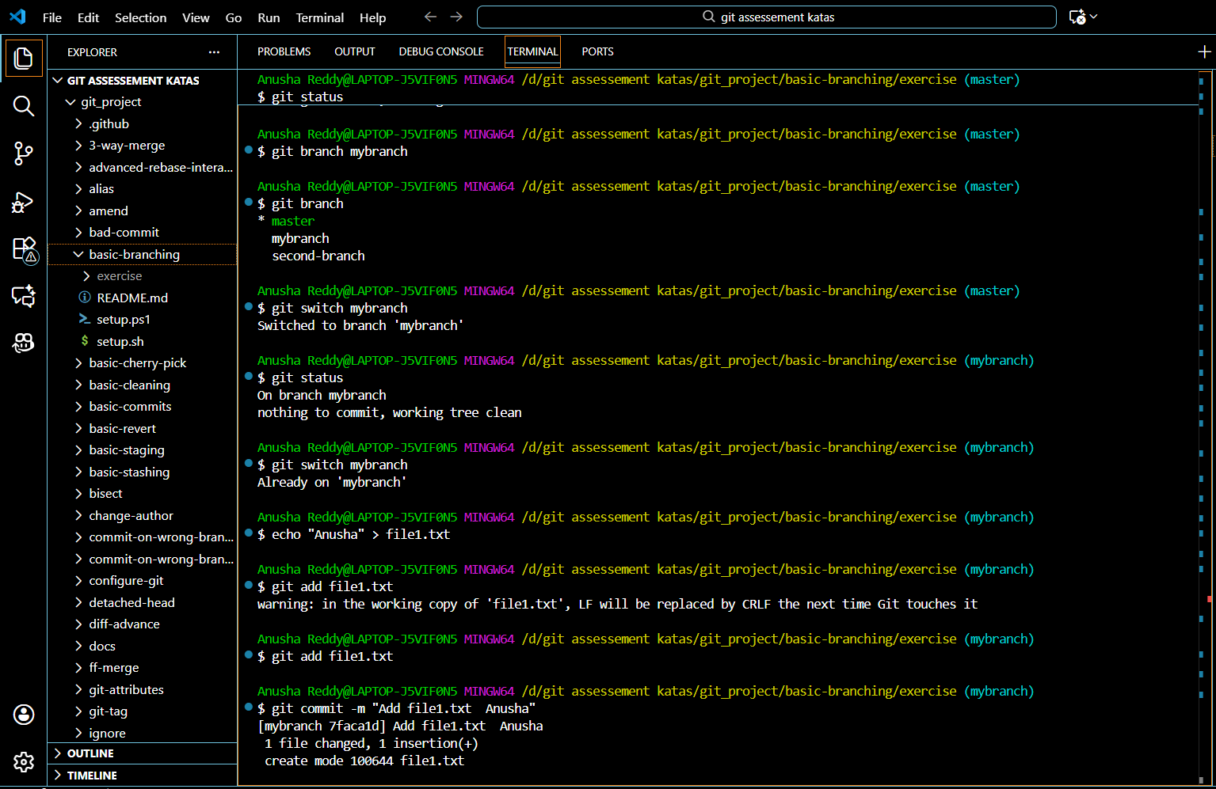

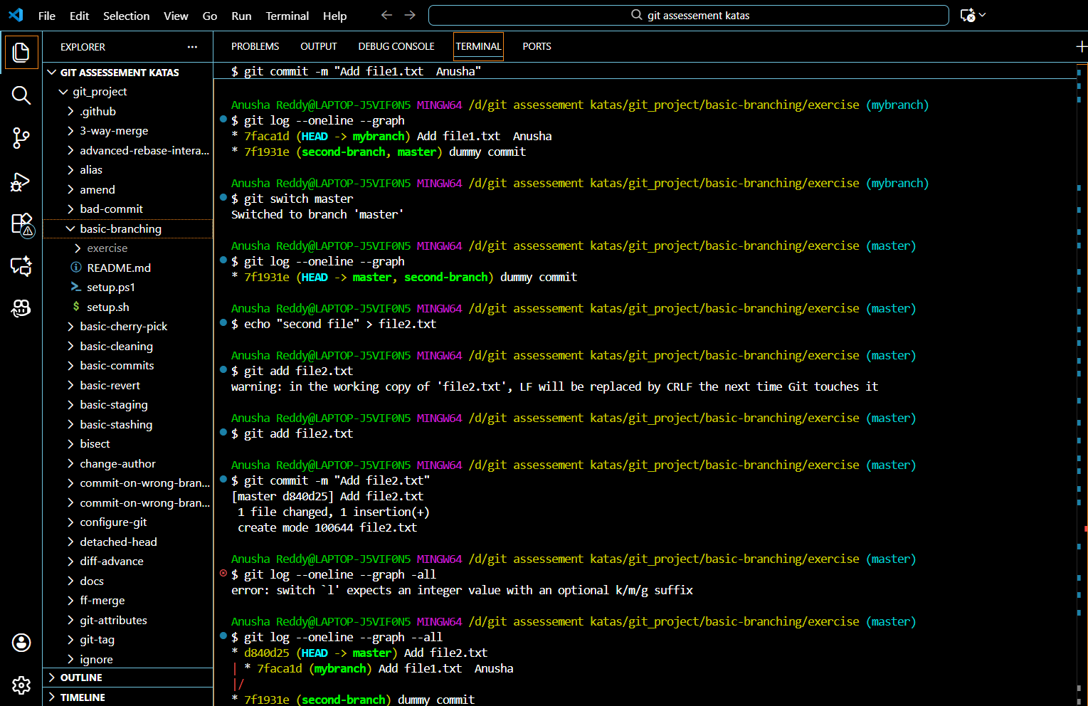

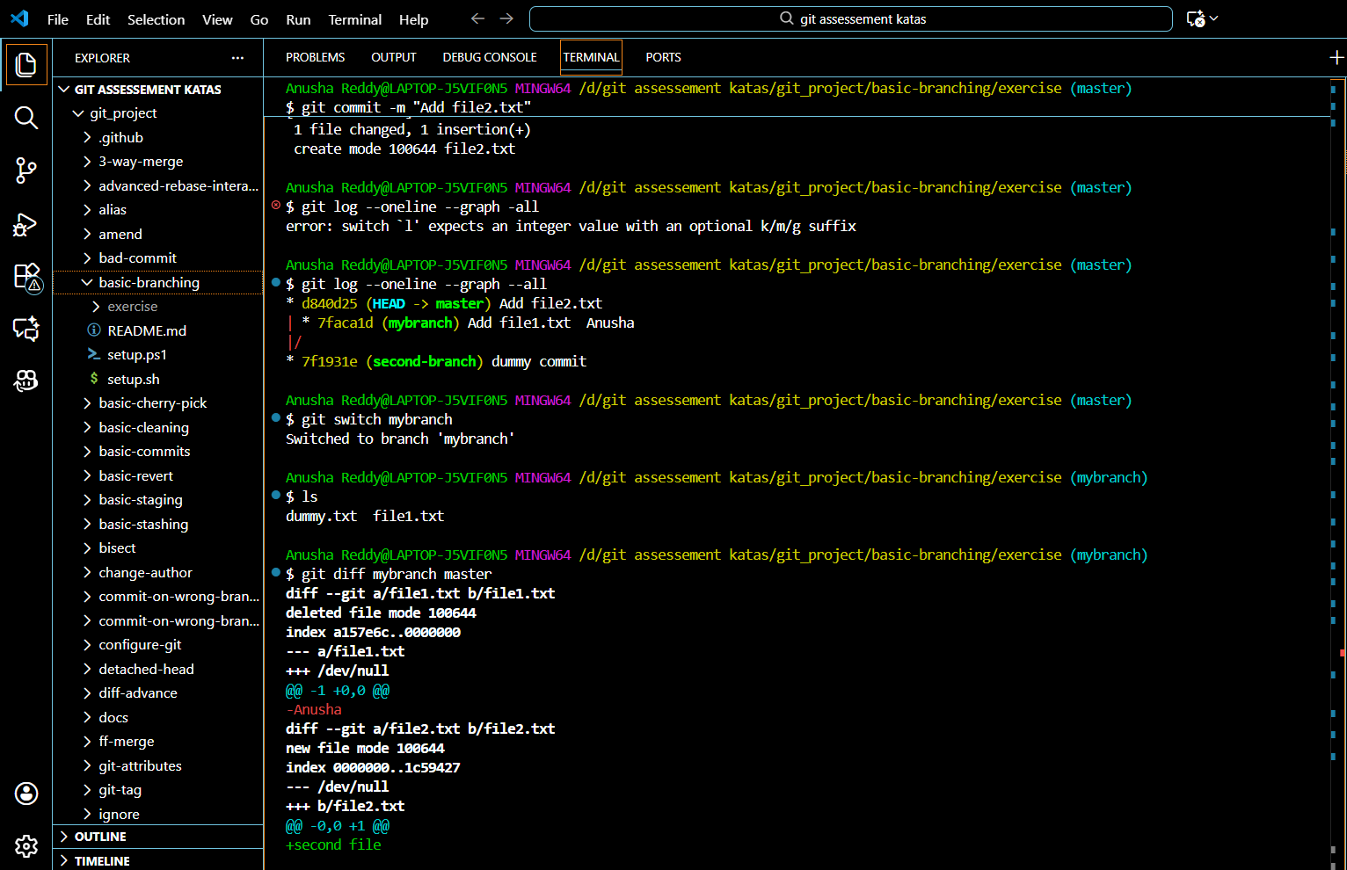

The commands used for the task:

git branch

git status

git branch mybranch

git branch

git switch mybranch

git status

git switch master

git status

git switch mybranch

echo "Your Name" > file1.txt

git add file1.txt

git commit -m "Add file1.txt with name"

git log --oneline --graph

git switch master

git log --oneline --graph

echo "second file" > file2.txt

git add file2.txt

git commit -m "Add file2.txt"

git log --oneline --graph --all

git switch mybranch

ls

git diff mybranch master

**FAST -FORWARD MERGE:**

This Git kata teaches how Git performs a fast-forward merge when the target branch has no divergent commits.

How Git moves branch pointers  
Why sometimes merges are simple  
How to avoid unnecessary merge commits  
How to keep history clean  
What happens when there is no conflict and no divergence

SETUP

Source [setup.sh](http://setup.sh)

The implementation:

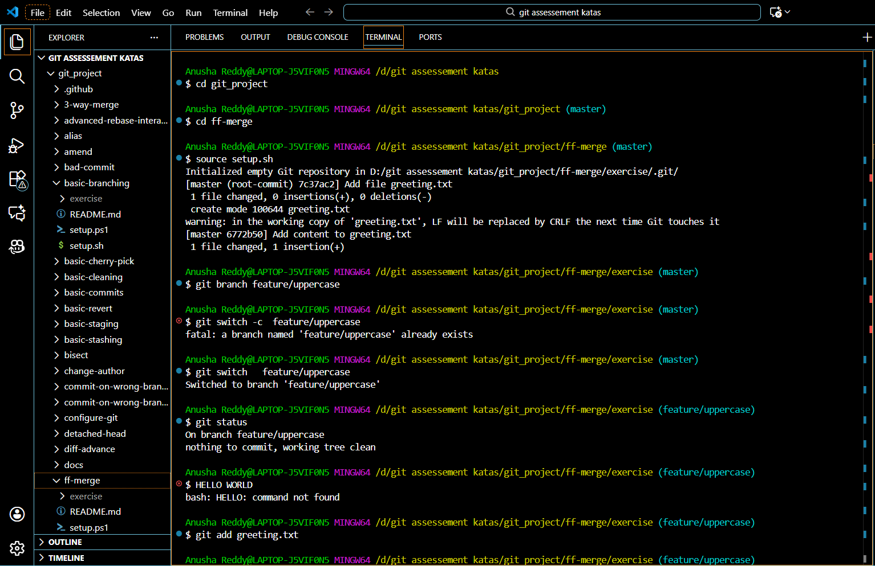

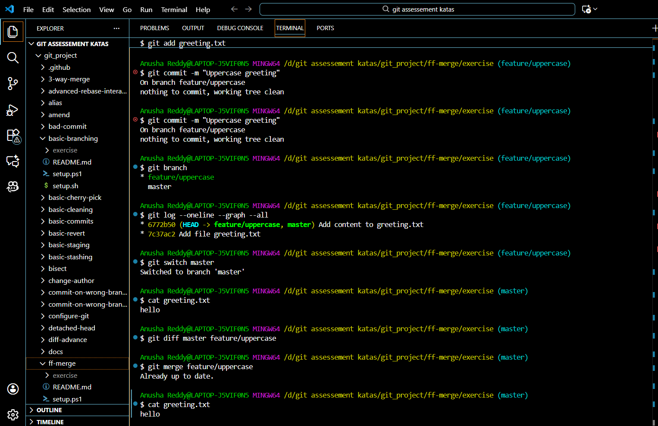

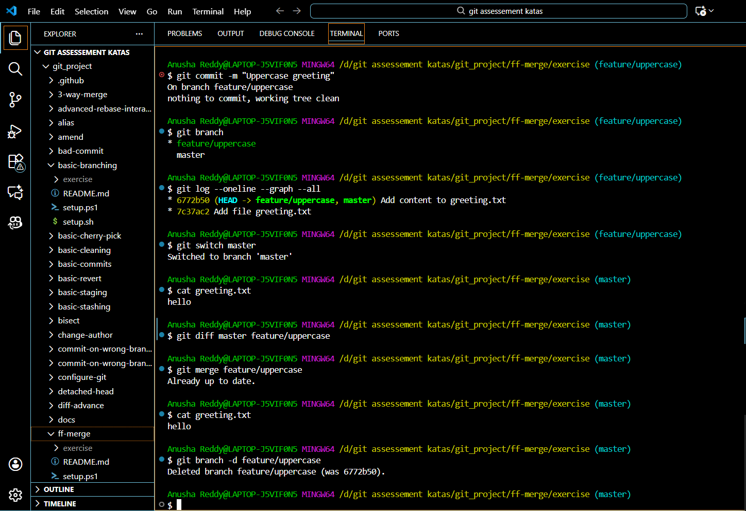

The commands used for implementation

git switch -c feature/uppercase

git status

# (edit greeting.txt to uppercase manually)

git add greeting.txt

git commit -m "Uppercase greeting"

git branch

git log --oneline --graph --all

git switch master

cat greeting.txt

git diff master feature/uppercase

git merge feature/uppercase

cat greeting.txt

git branch -d feature/uppercase

# **3-Way Merge**

# SETUP

# Source [setup.sh](http://setup.sh)

The Implementation:

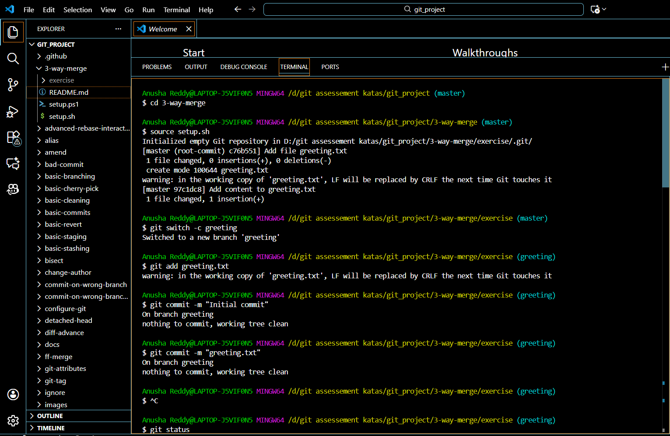

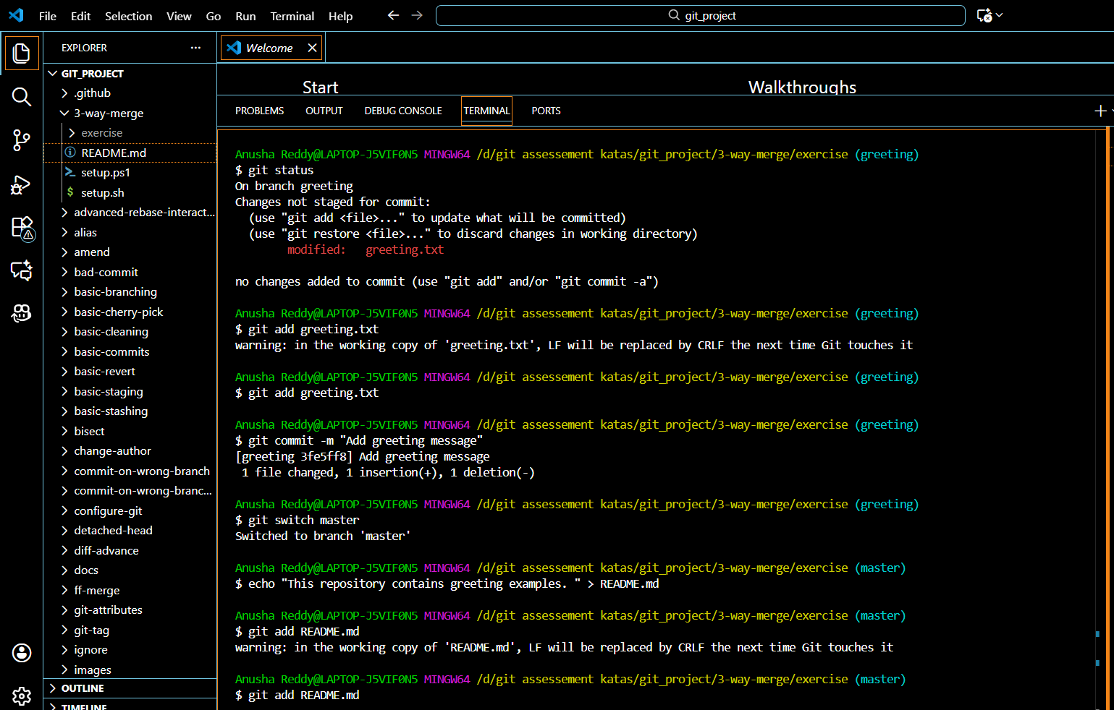

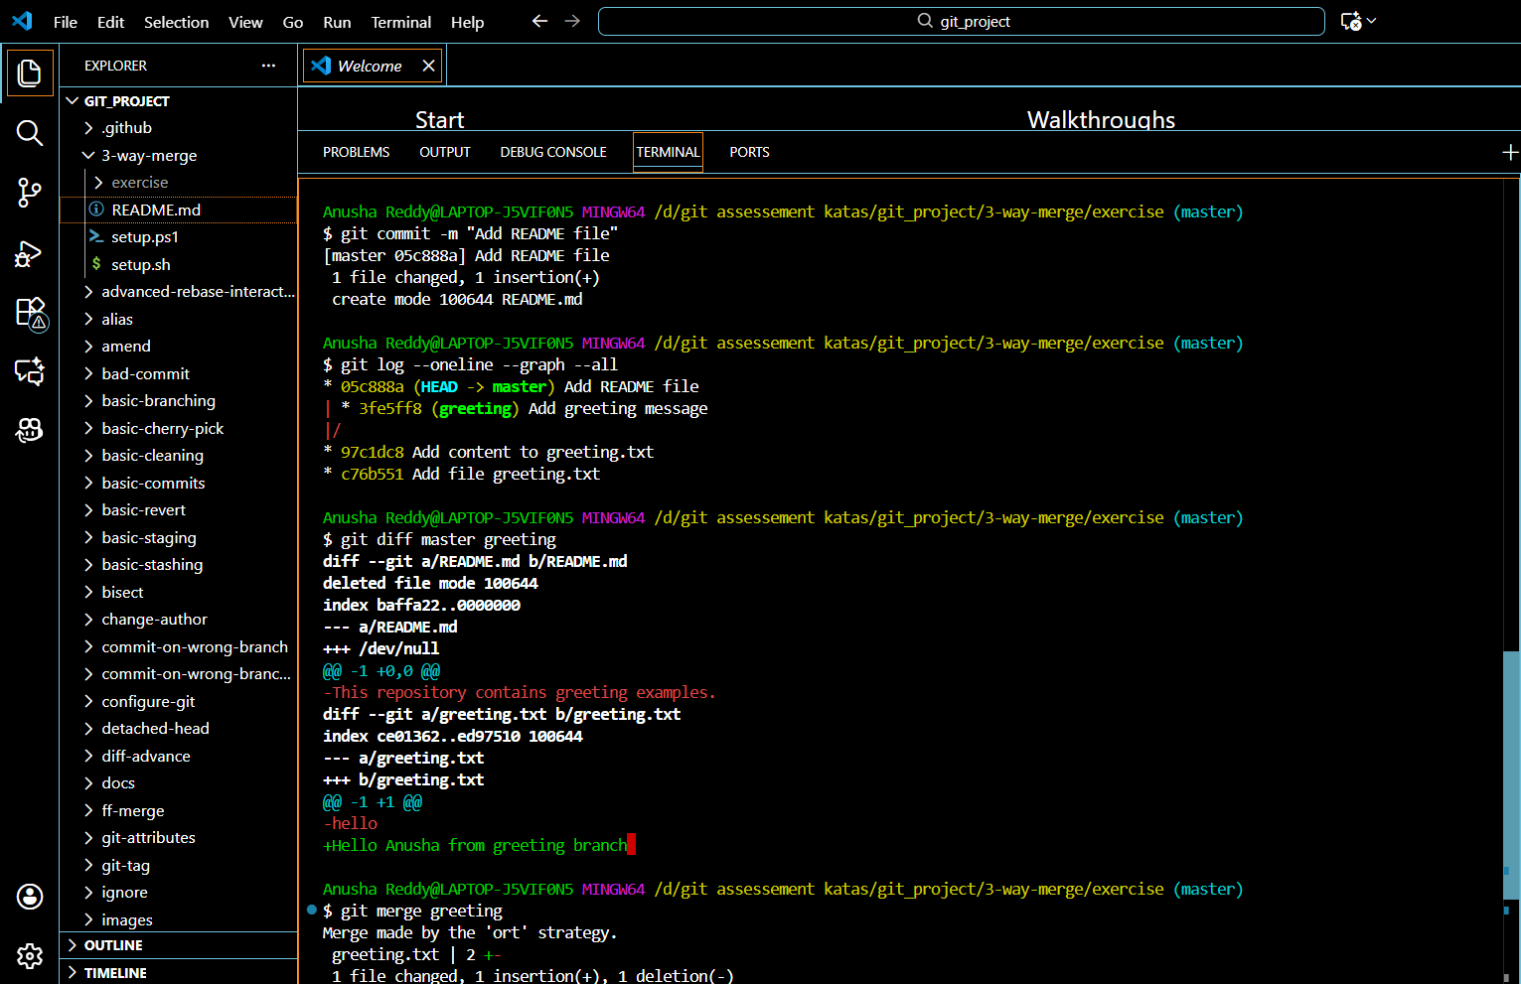

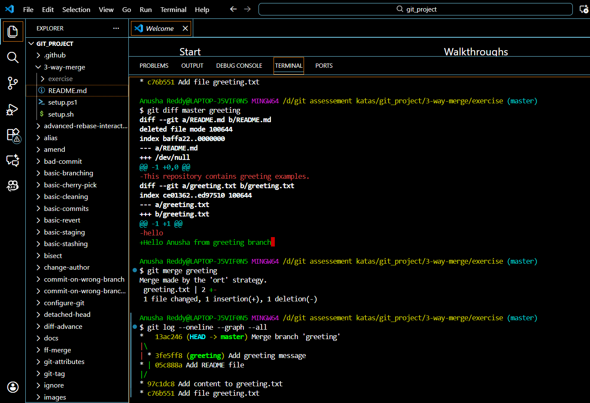

The commands used for the task

git switch -c greeting

git add greeting.txt

git commit -m "Add favorite greeting"

git switch master

echo "This repository contains greeting examples." > README.md

git add README.md

git commit -m "Add README file"

git log --oneline --graph --all

git diff master greeting

git merge greeting git log --oneline --graph --all

# **Merge Conflict:**

# SETUP

# Source [setup.sh](http://setup.sh)

**The implementation :**

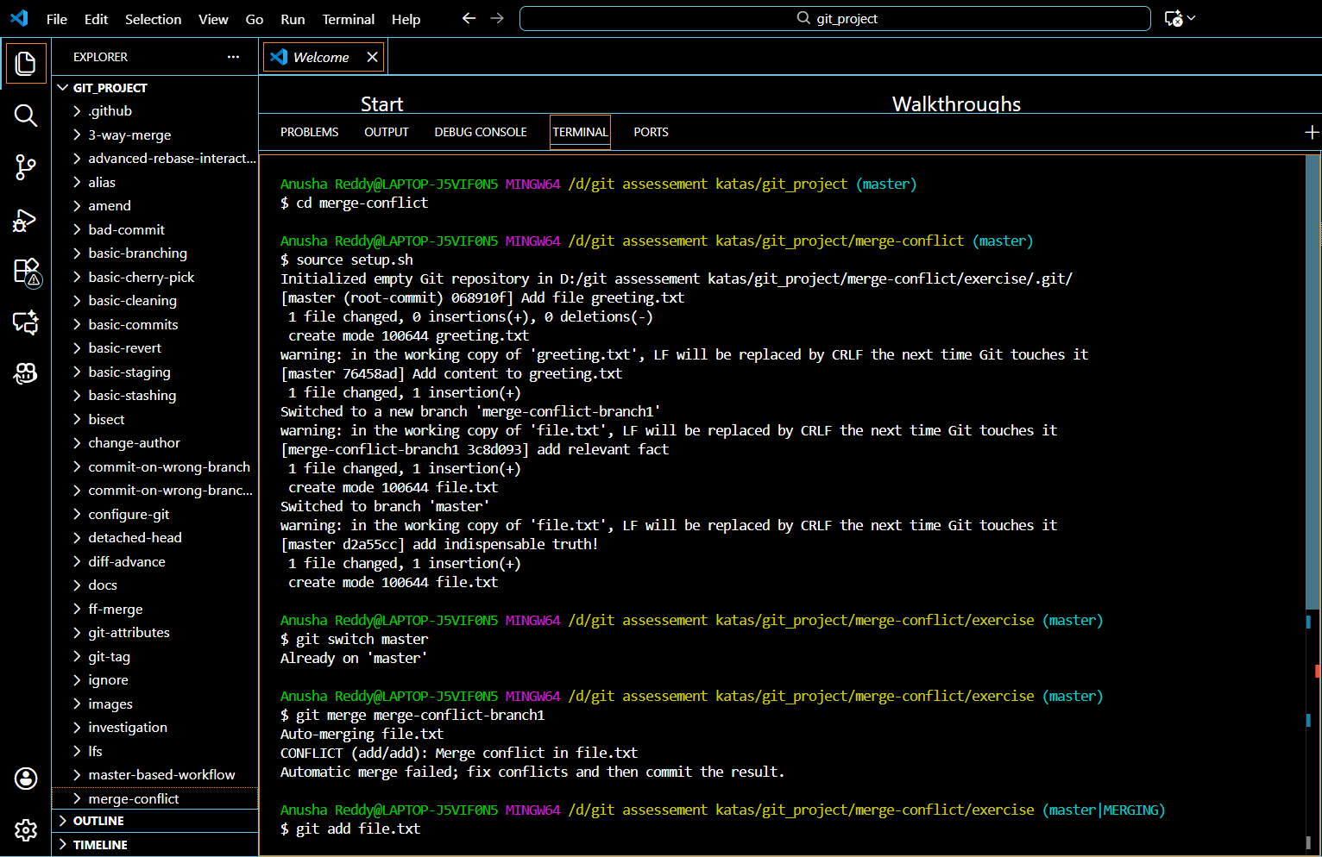

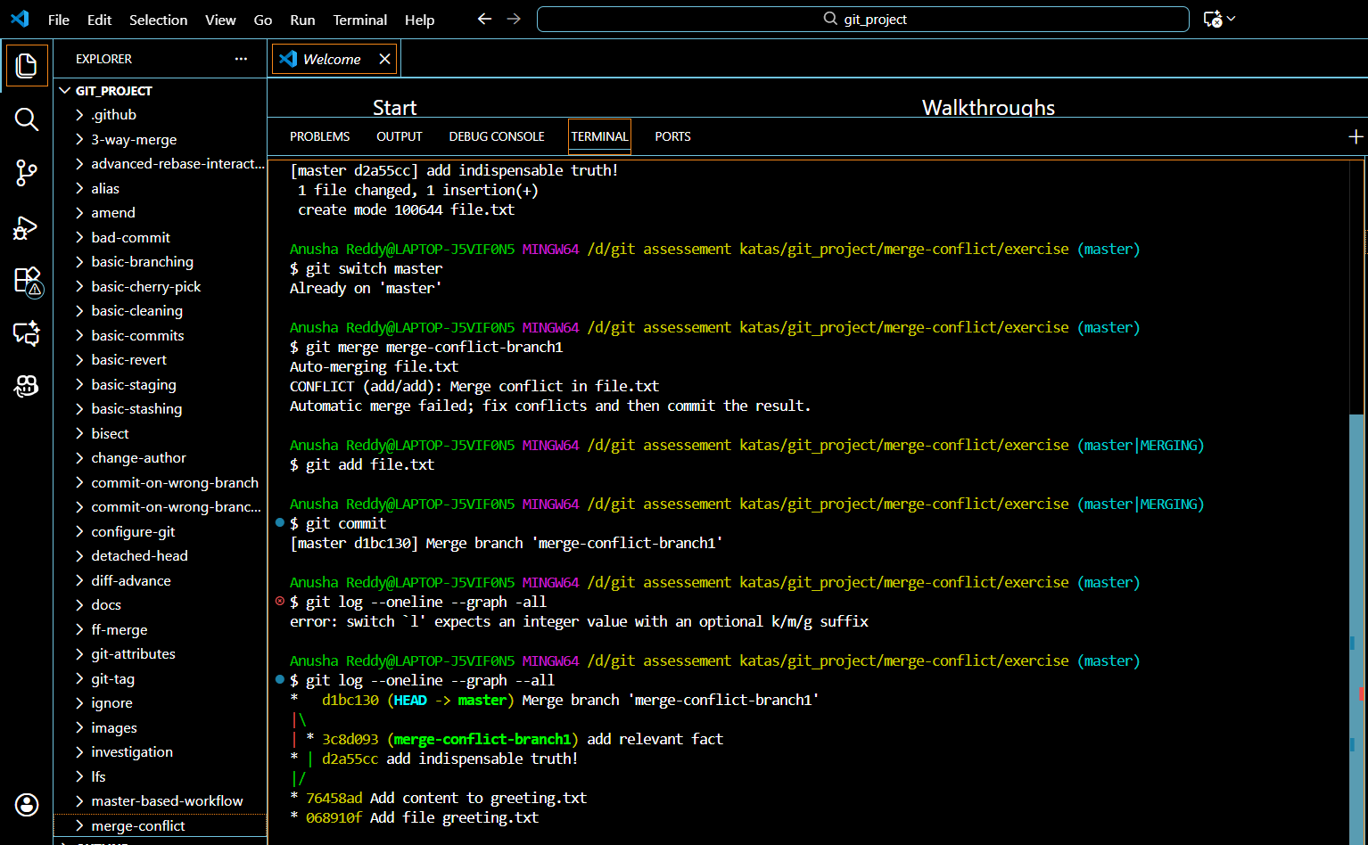

The commands used for the task implementation:

git checkout mastergit checkout master

git merge merge-conflict-branch1

git status

git add <filename>

git commit

git log --oneline --graph --all  
  
**Merge Mergesort**

# SETUP

# Source [setup.sh](http://setup.sh)

Task:

The Implementation:

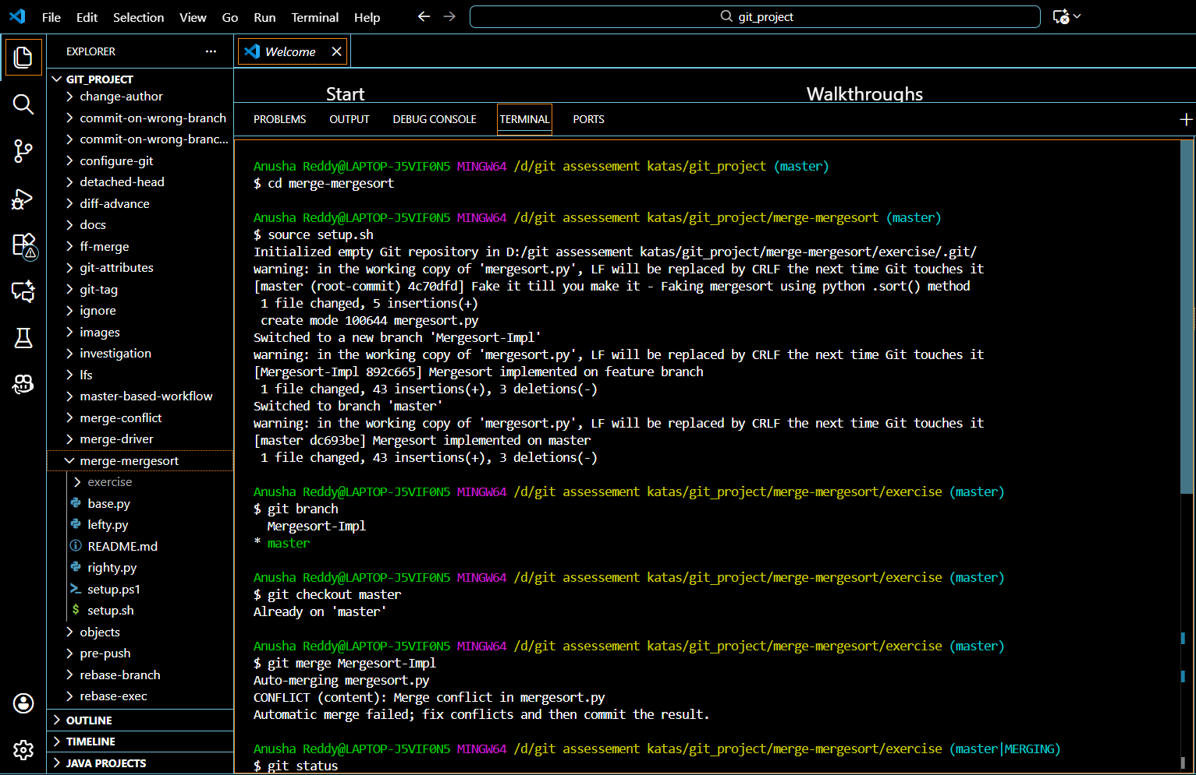

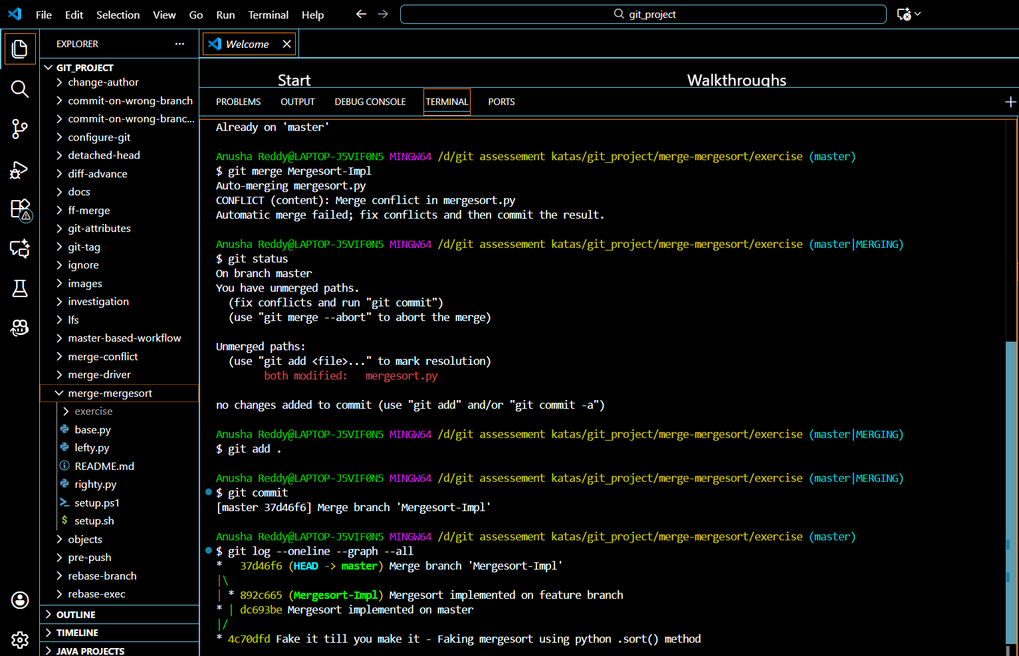

The commands used for the task implementation:

git branch

git checkout master

git merge Mergesort-Impl

git status

git mergetool --tool

git add .

git commit

git log --oneline --graph --all

# **Rebase branch:**

# SETUP Source [setup.sh](http://setup.sh)

The implementation:

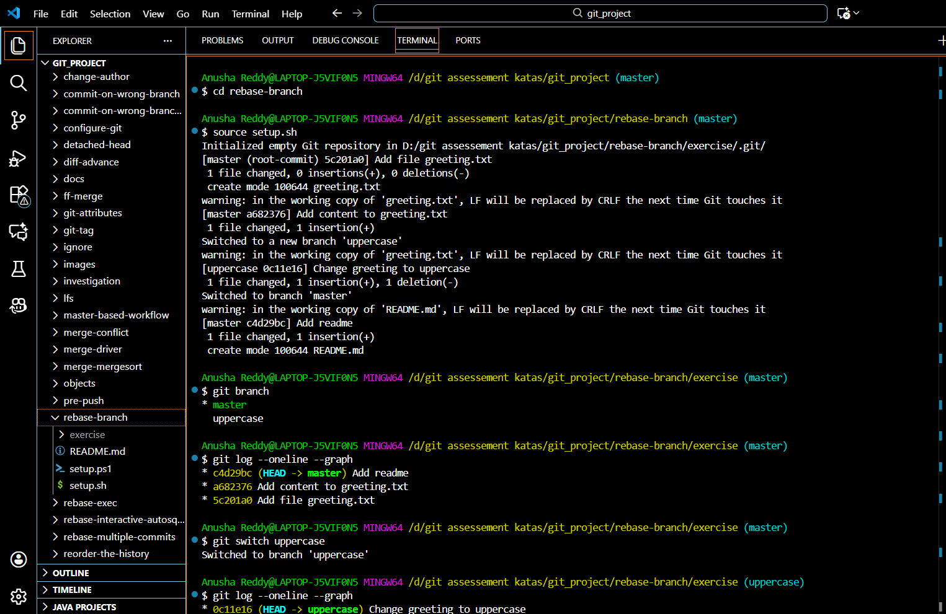

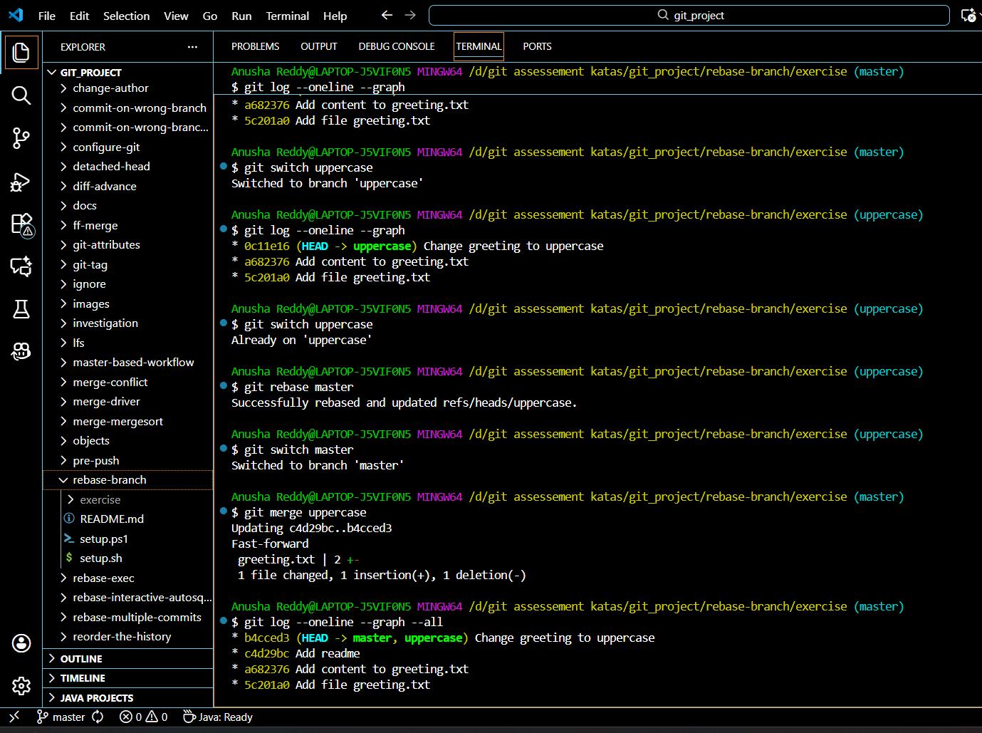

The commands used for the task implementation

git branch

git log --oneline --graph

git switch uppercase

git log --oneline --graph

git switch master

git merge uppercase

git log --oneline --graph --all

# **Basic revert :**

SETUP -source [setup.sh](http://setup.sh)

The implementation

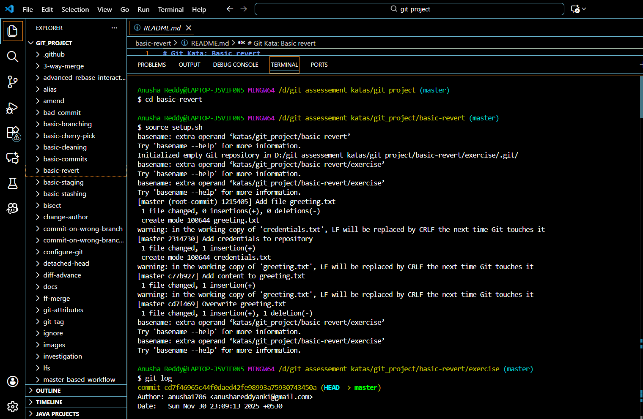

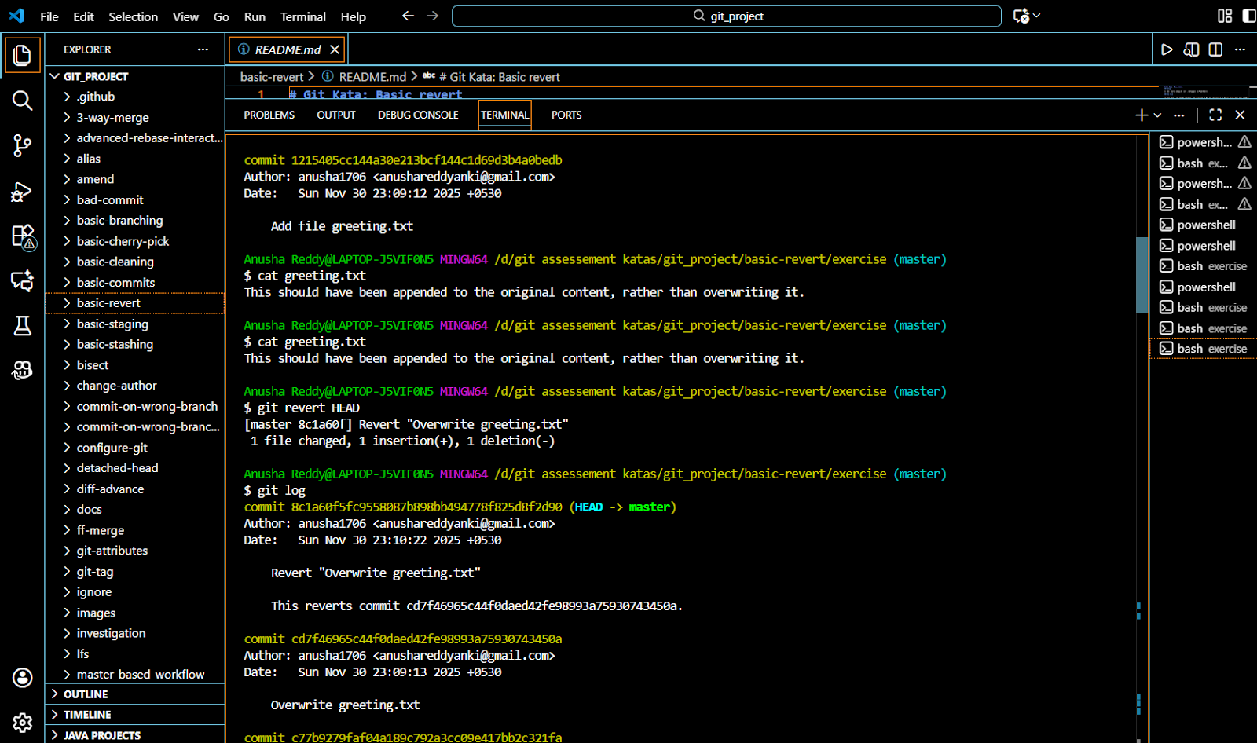

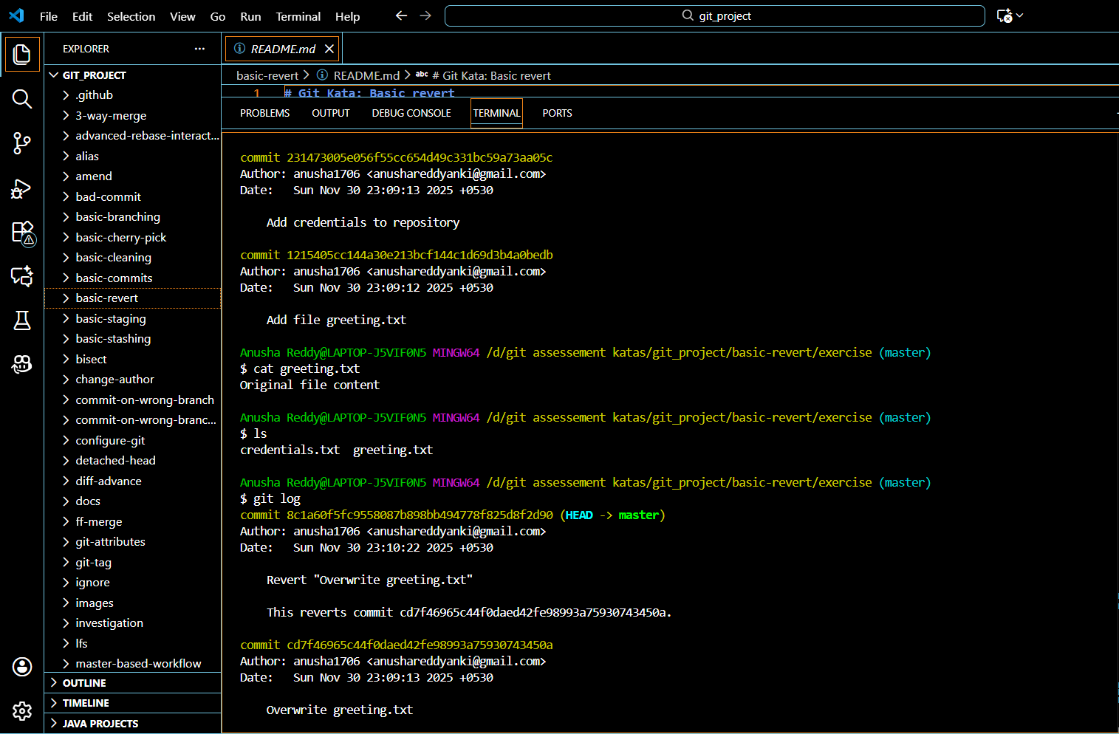

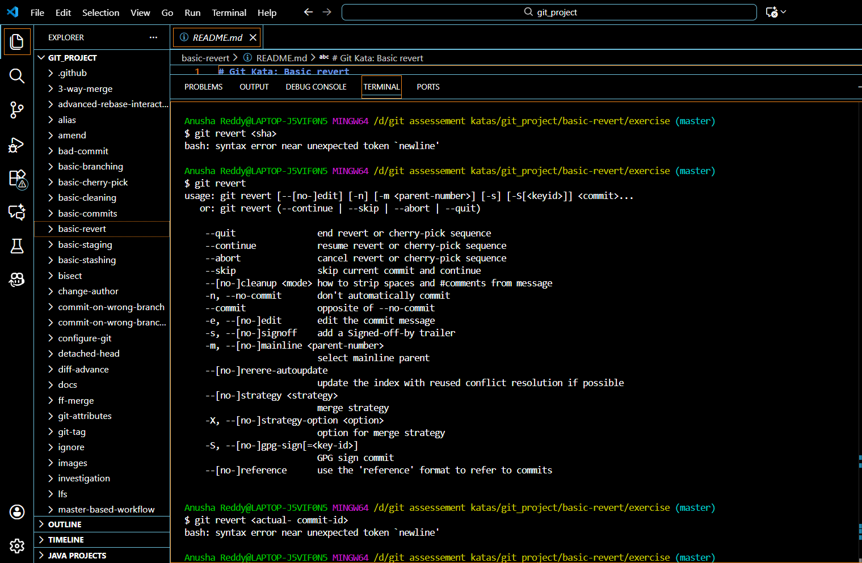

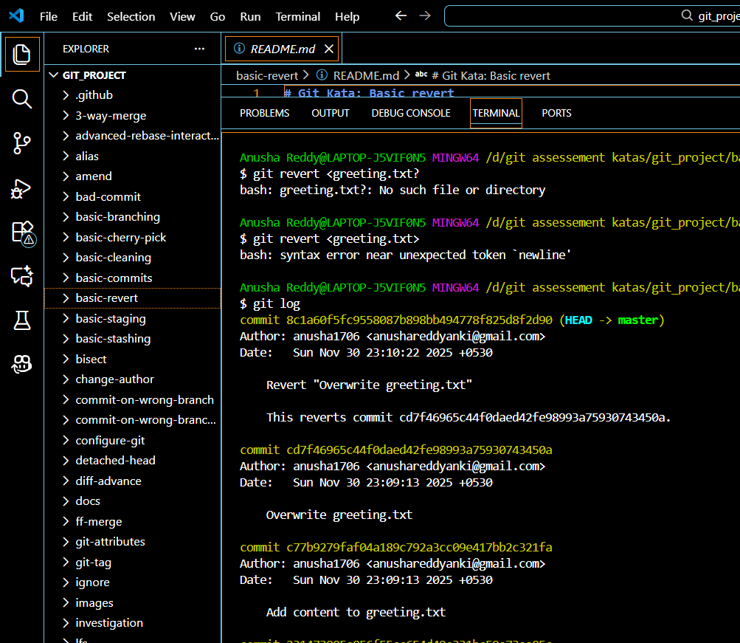

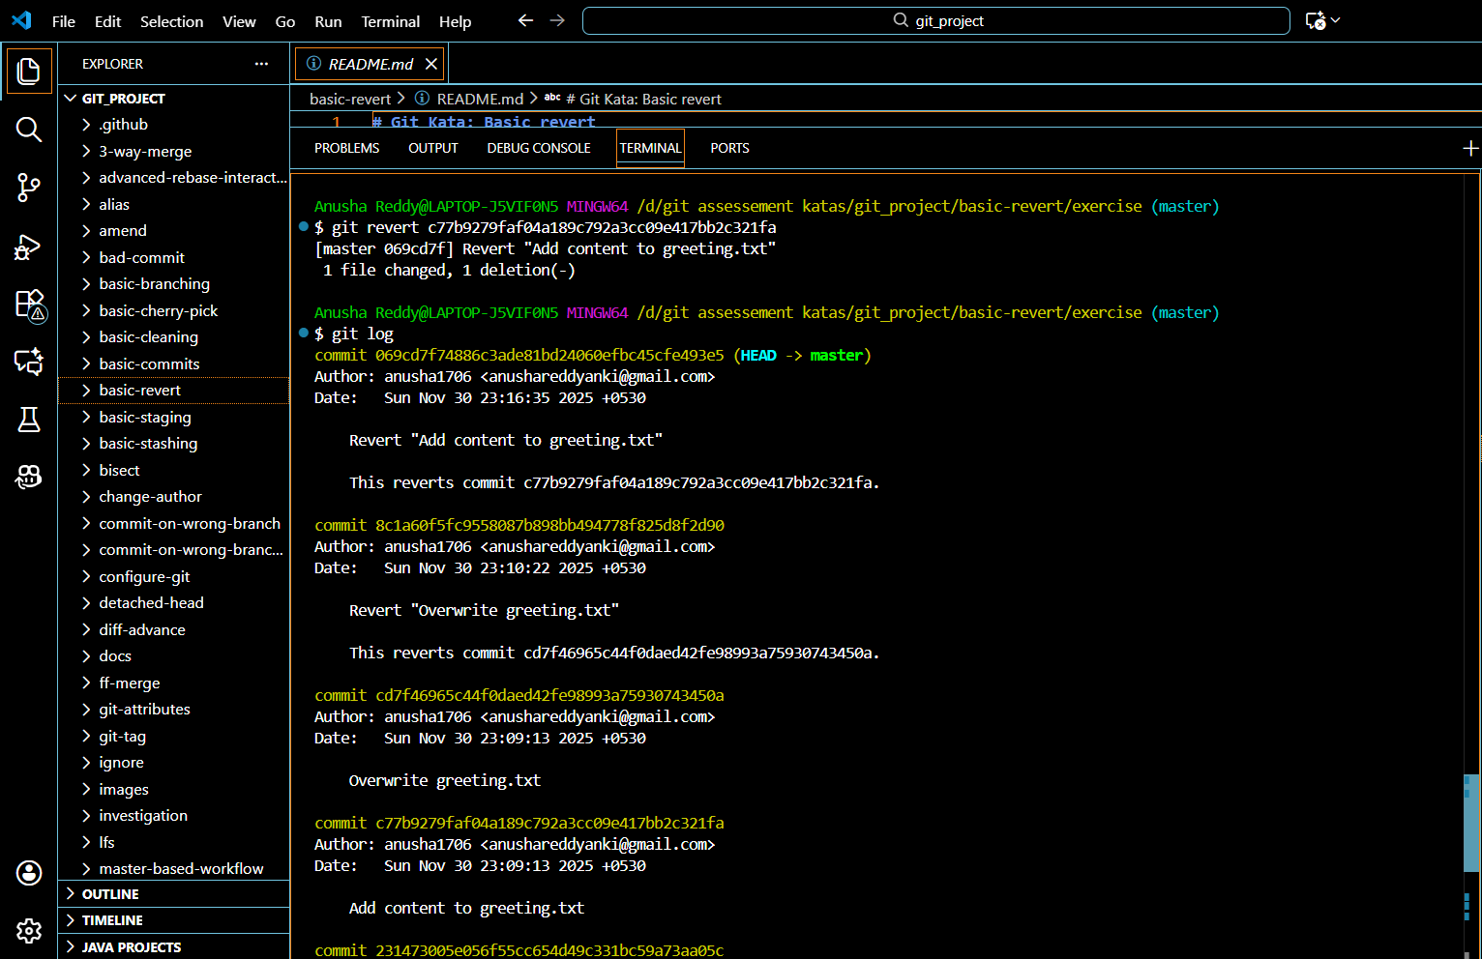

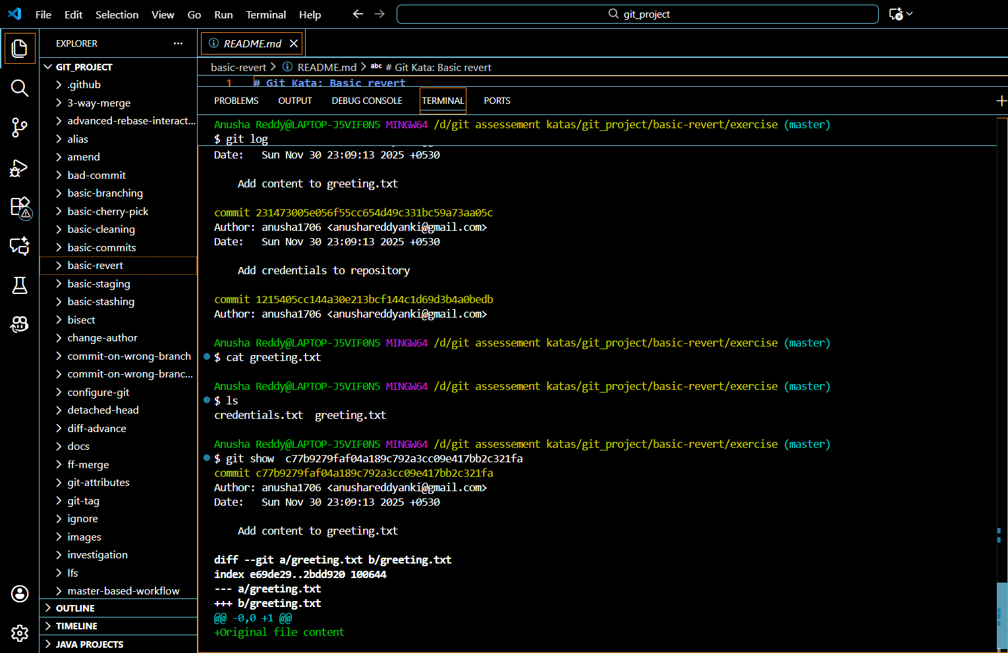

# **Git reset**

SETUP :source [setup.sh](http://setup.sh)

The implementation

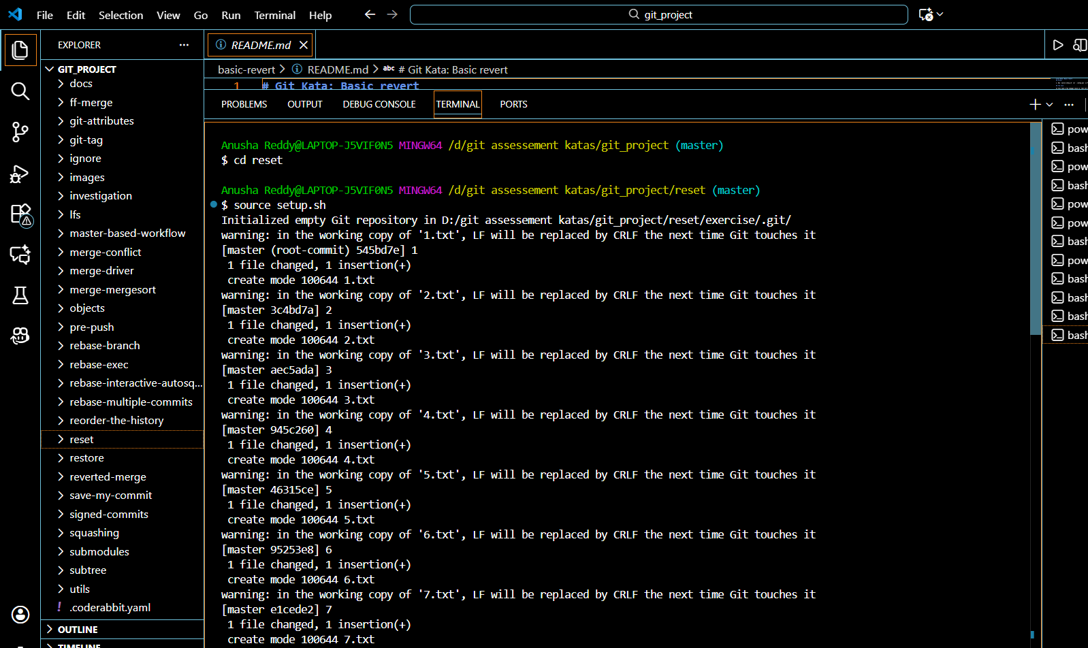

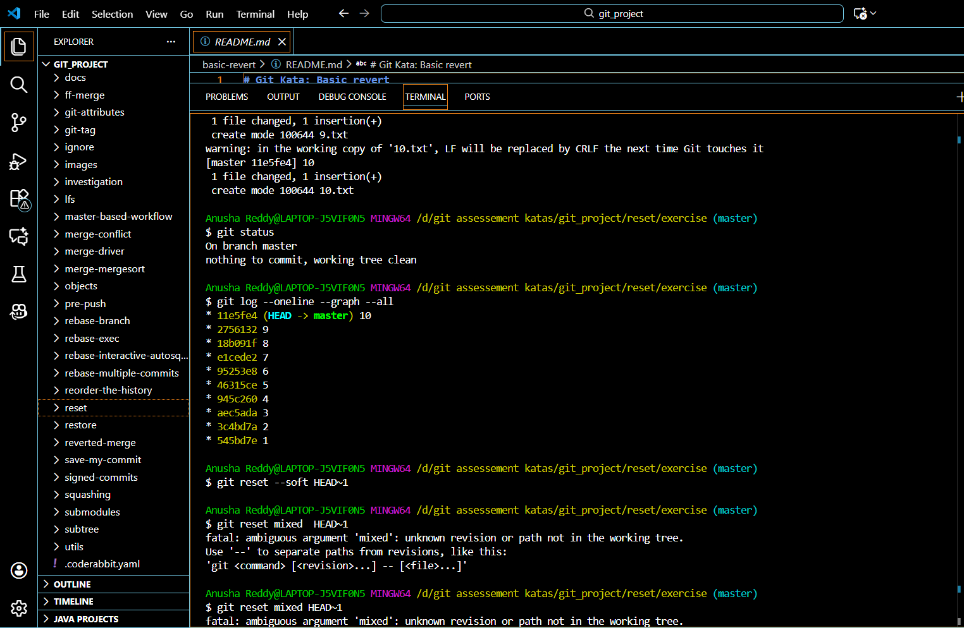

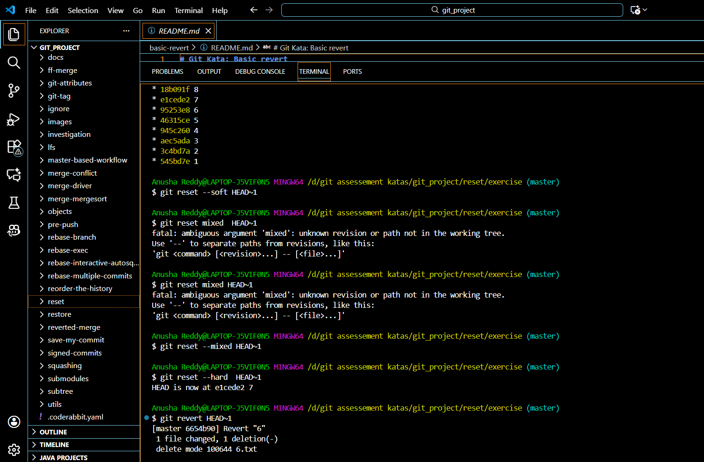

**BASIC STASHING :**

SETUP

Source [setup.sh](http://setup.sh)

The implementation of the task

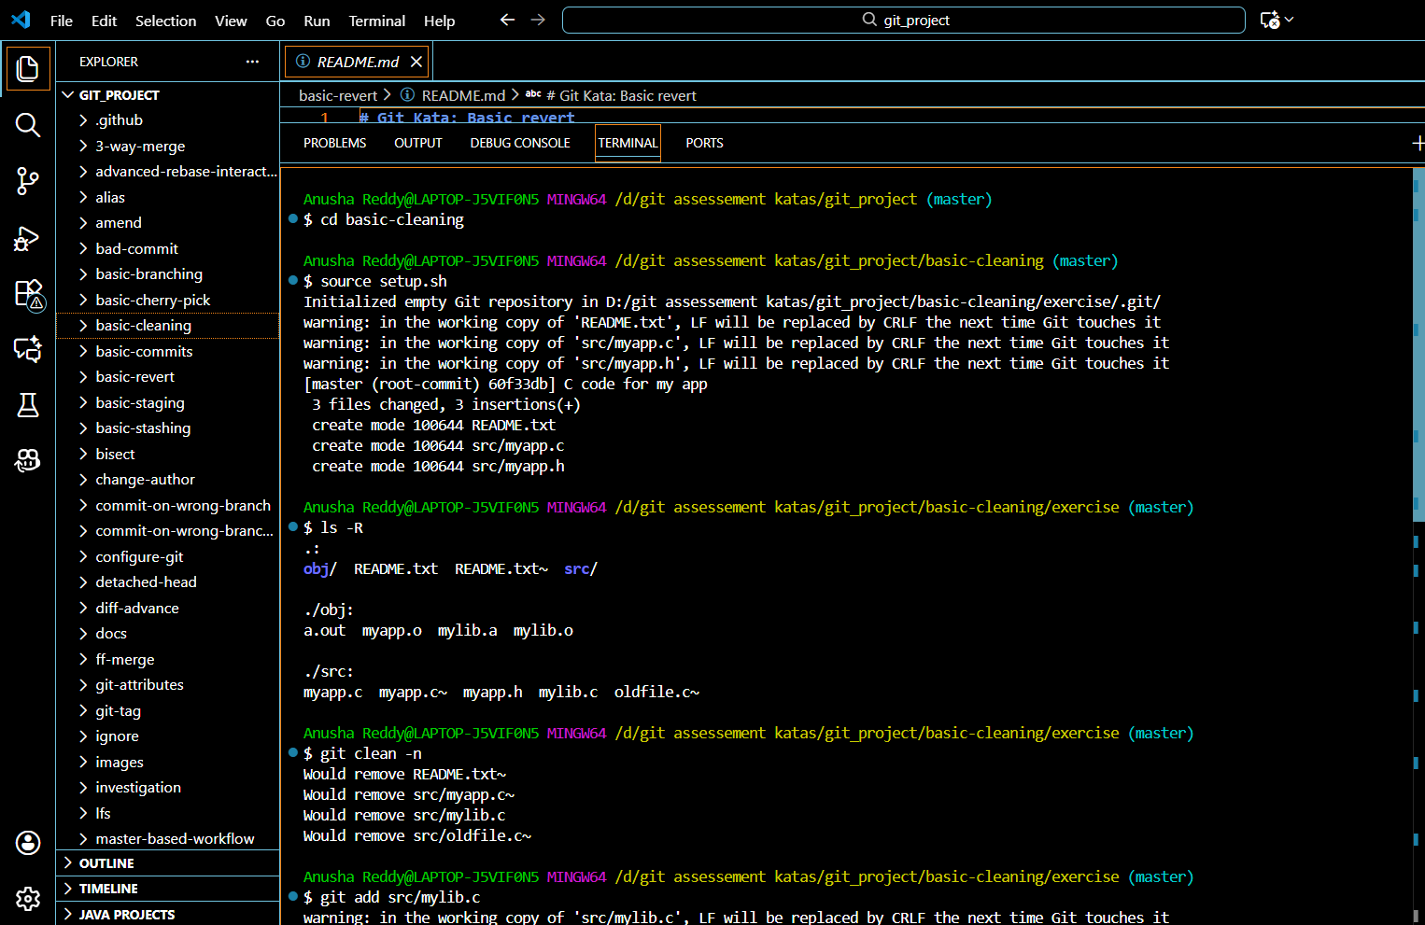

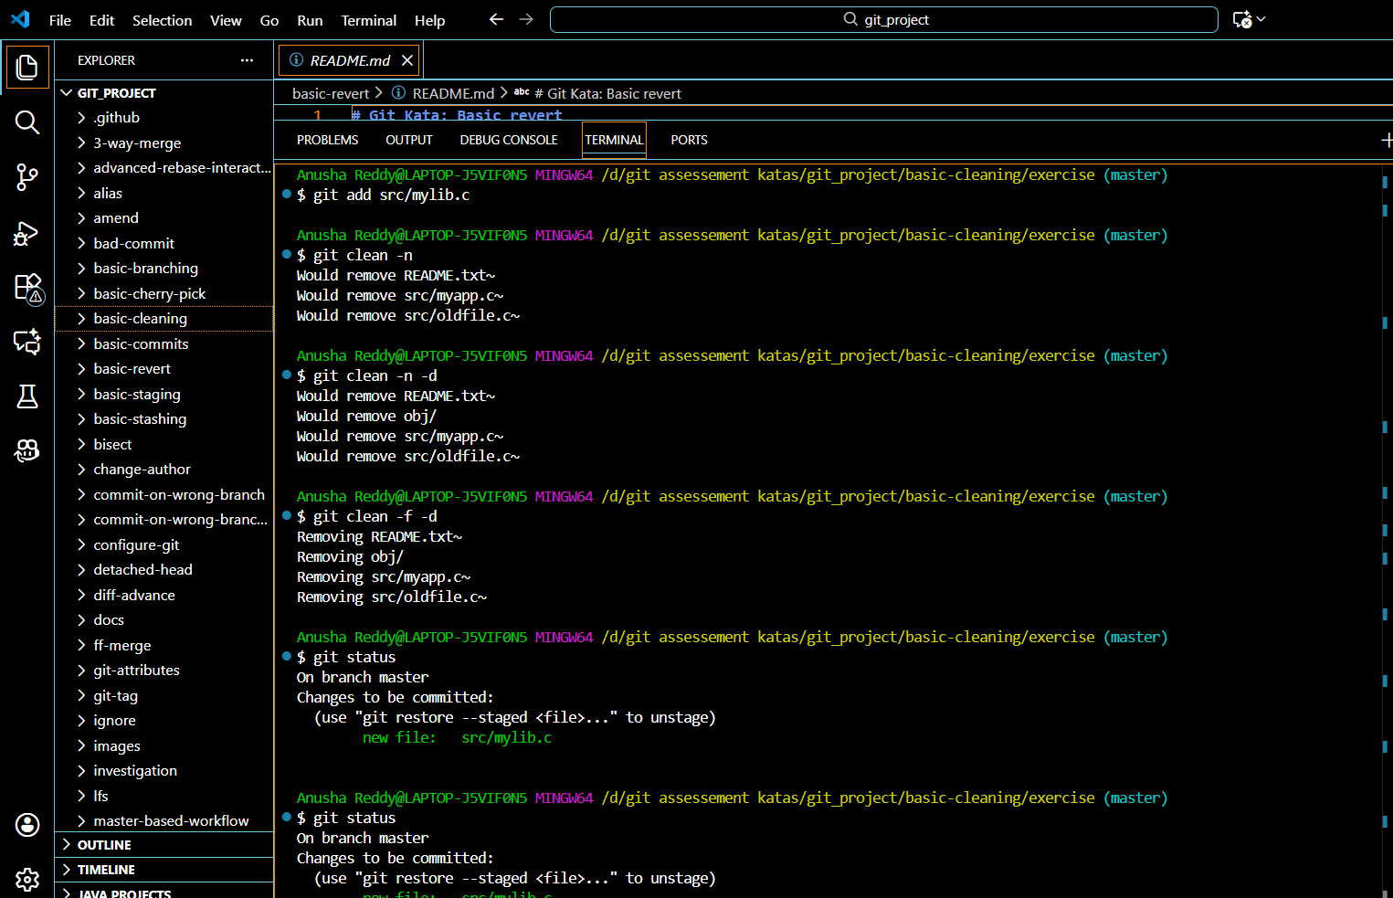

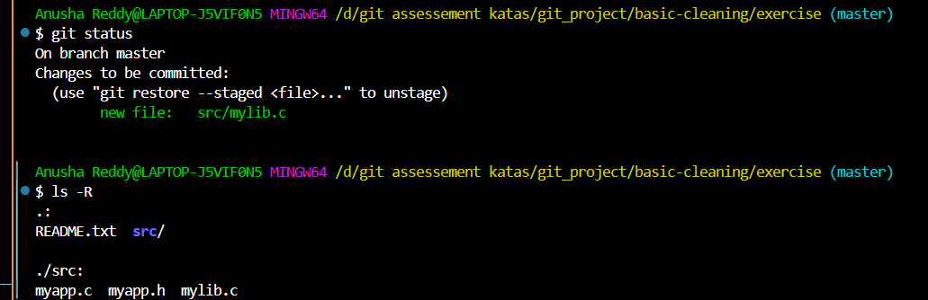

# **Amending commits**

SETUP : source [setup.sh](http://setup.sh)

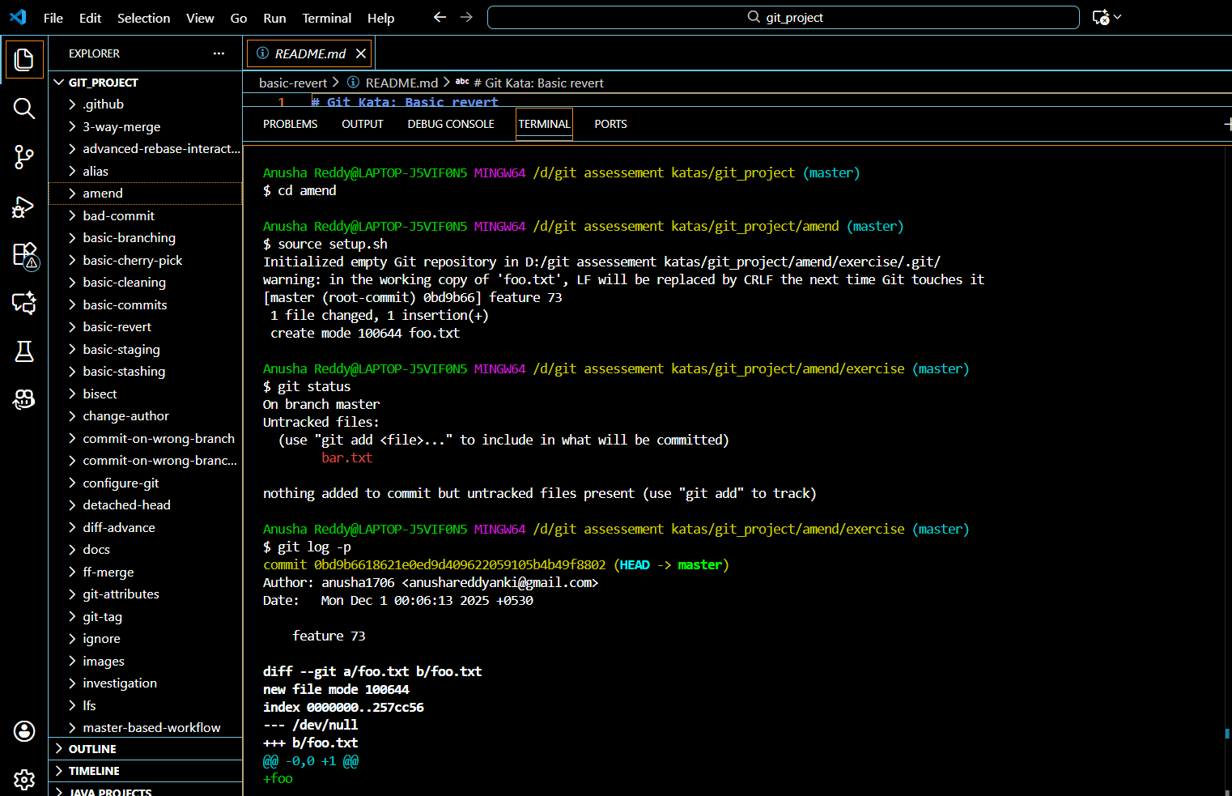

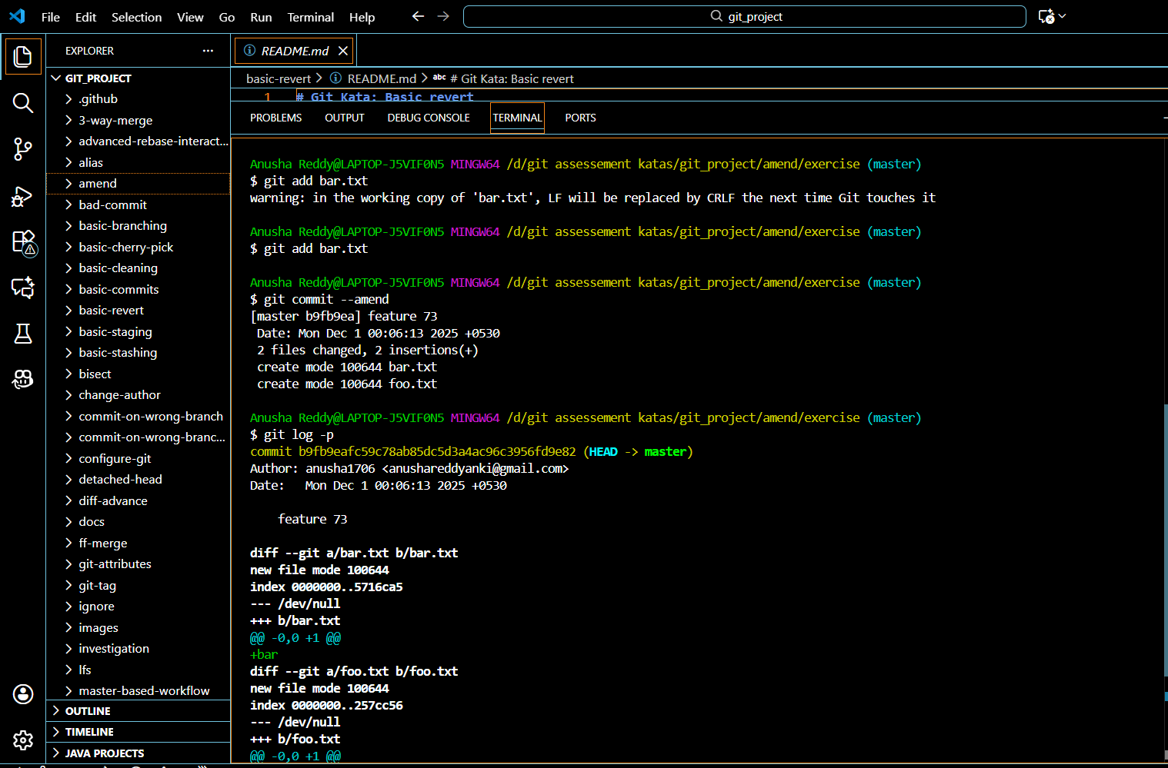

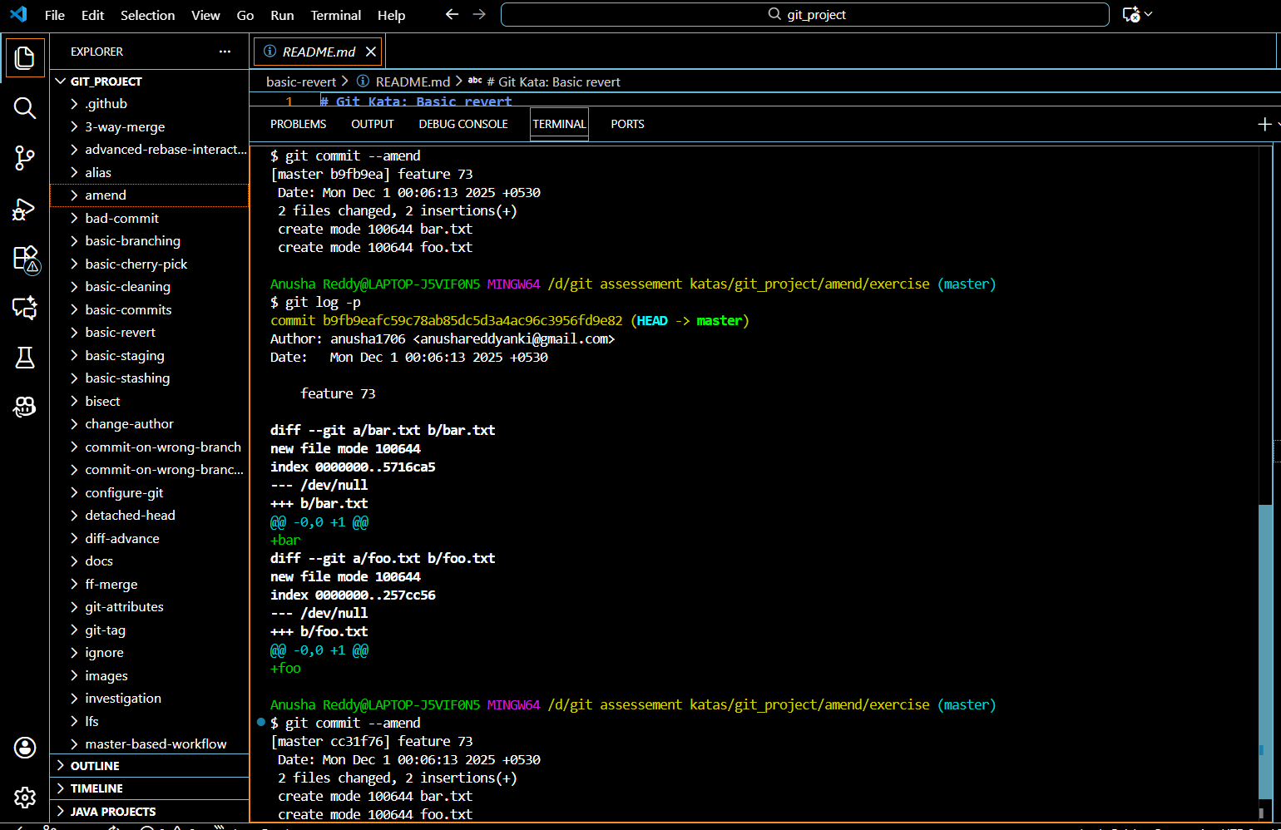

The commands used for execution

git status

git log -p

git add bar.txt

git commit --amend

git log -p

git commit --amend

## **Reordering history**

Setup - source [setup.sh](http://setup.sh)

The implementation

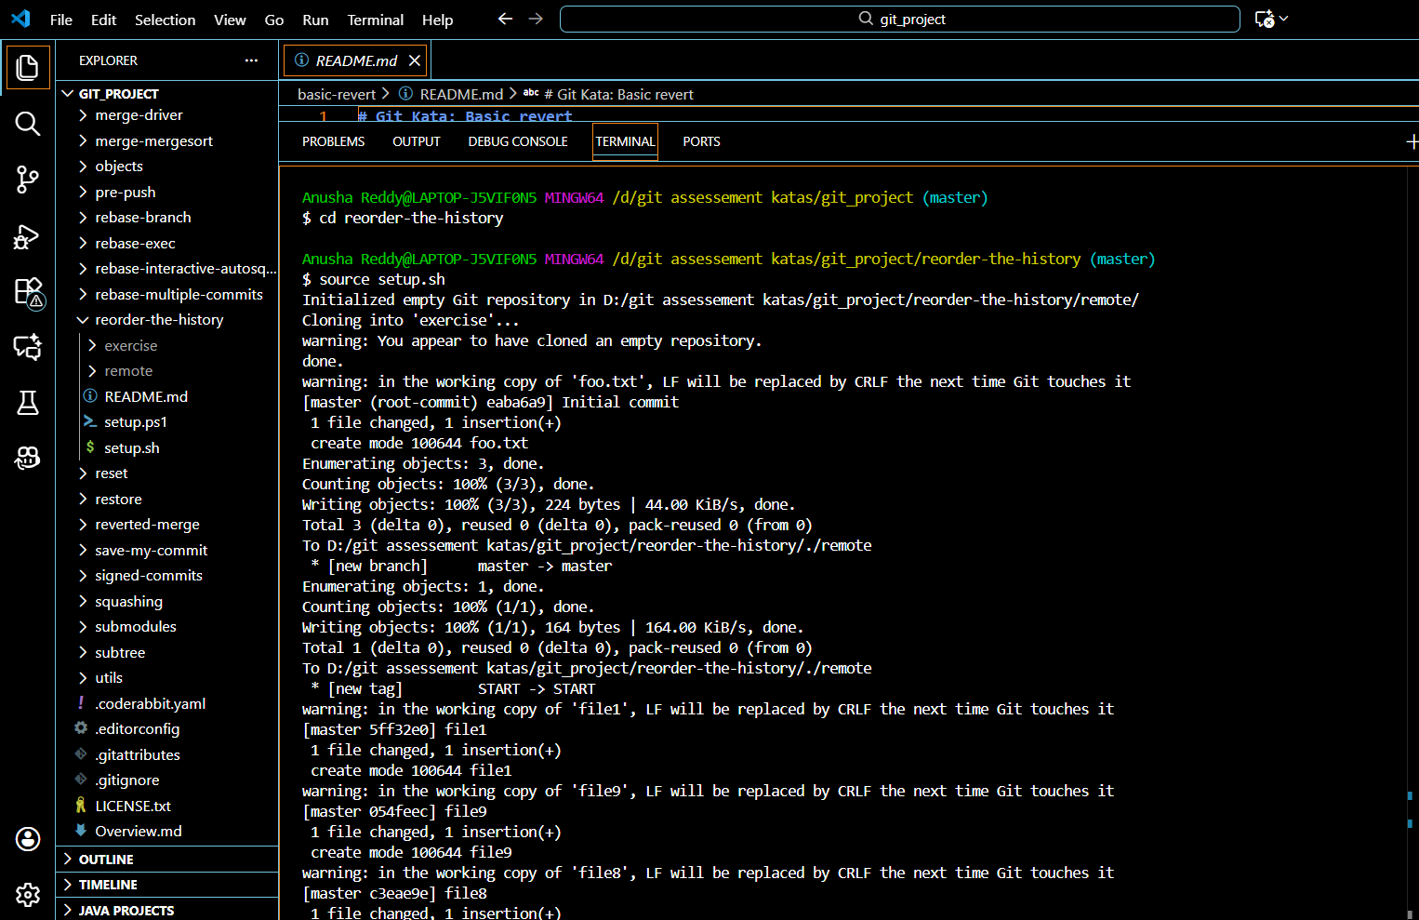

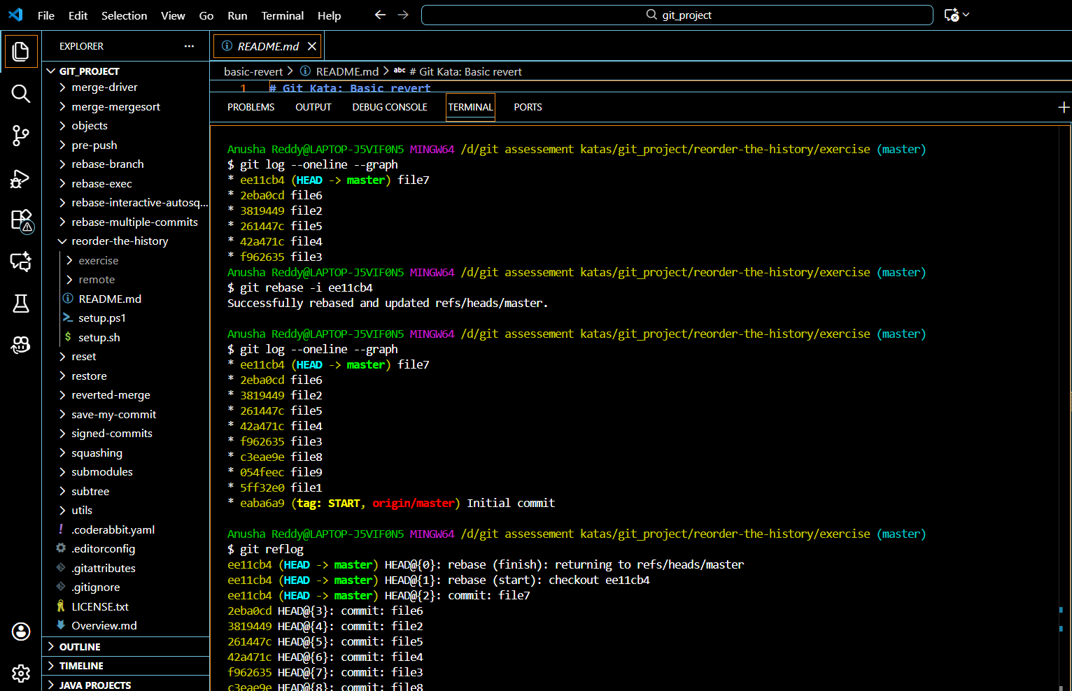

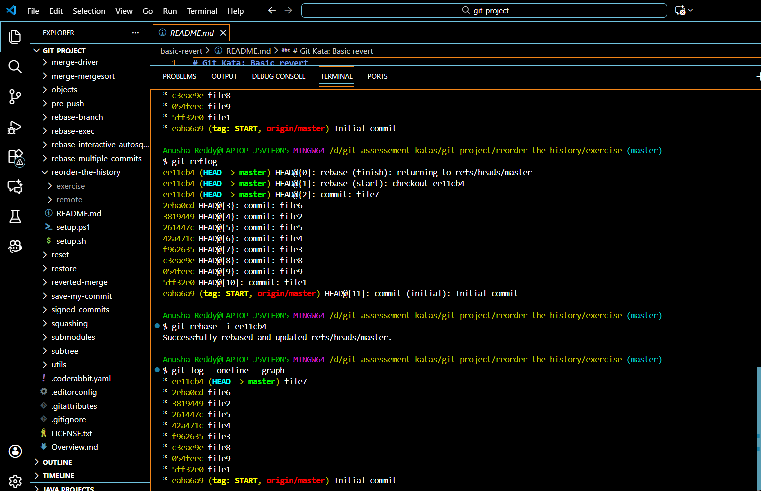

The commands for execution

git log --oneline --graph

git reflog

git rebase -i <after-this-commit>

git log --oneline --graph

# **Squash commits**

Setup : source [setup.sh](http://setup.sh)

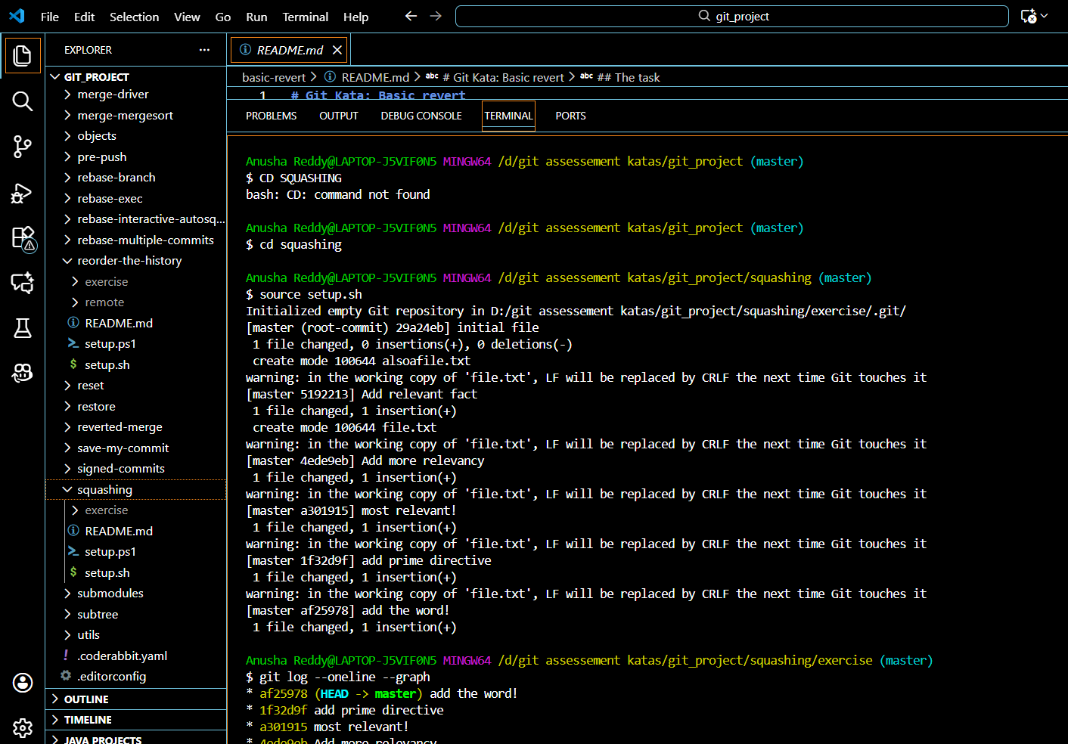

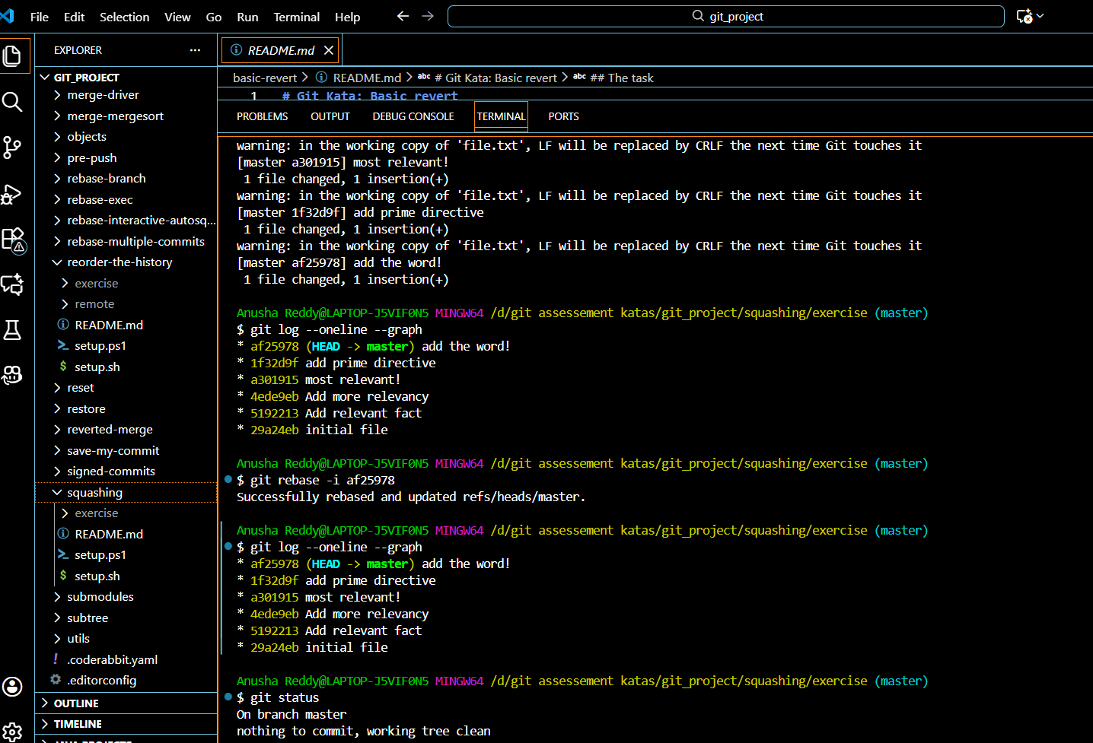

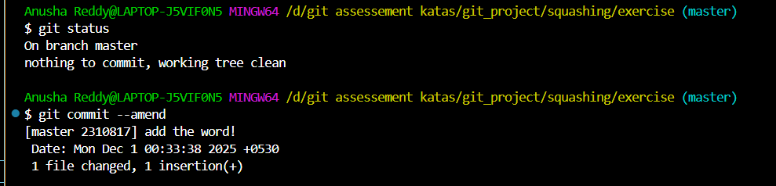

The commands used for implementing

git log – online –graph

git rebase -i <commit _id>

git status

git commit –amend

## **Advanced interactive rebase**

Setup : source [setup.sh](http://setup.sh)

The Implementation

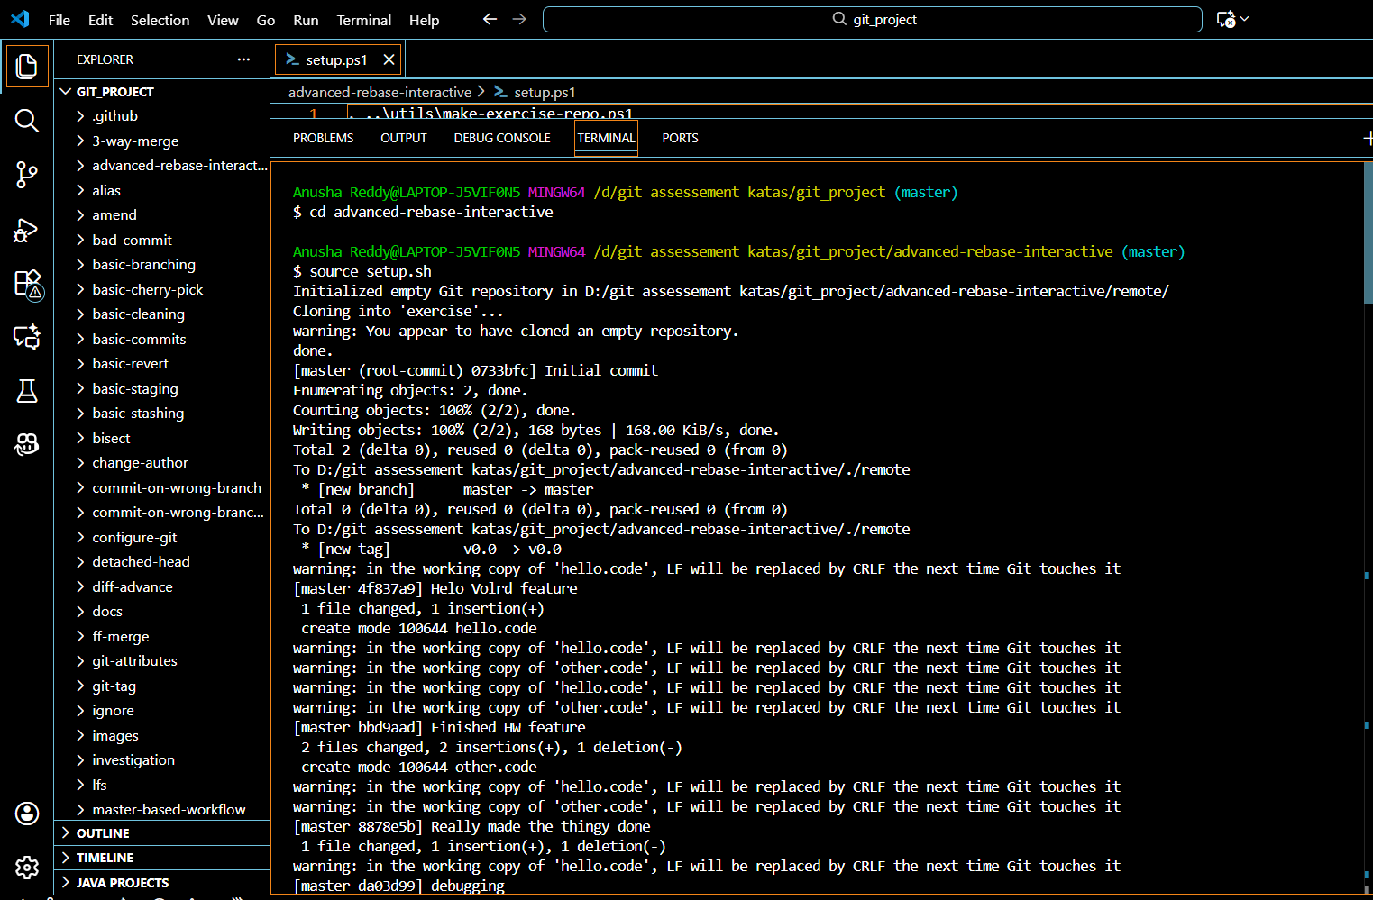

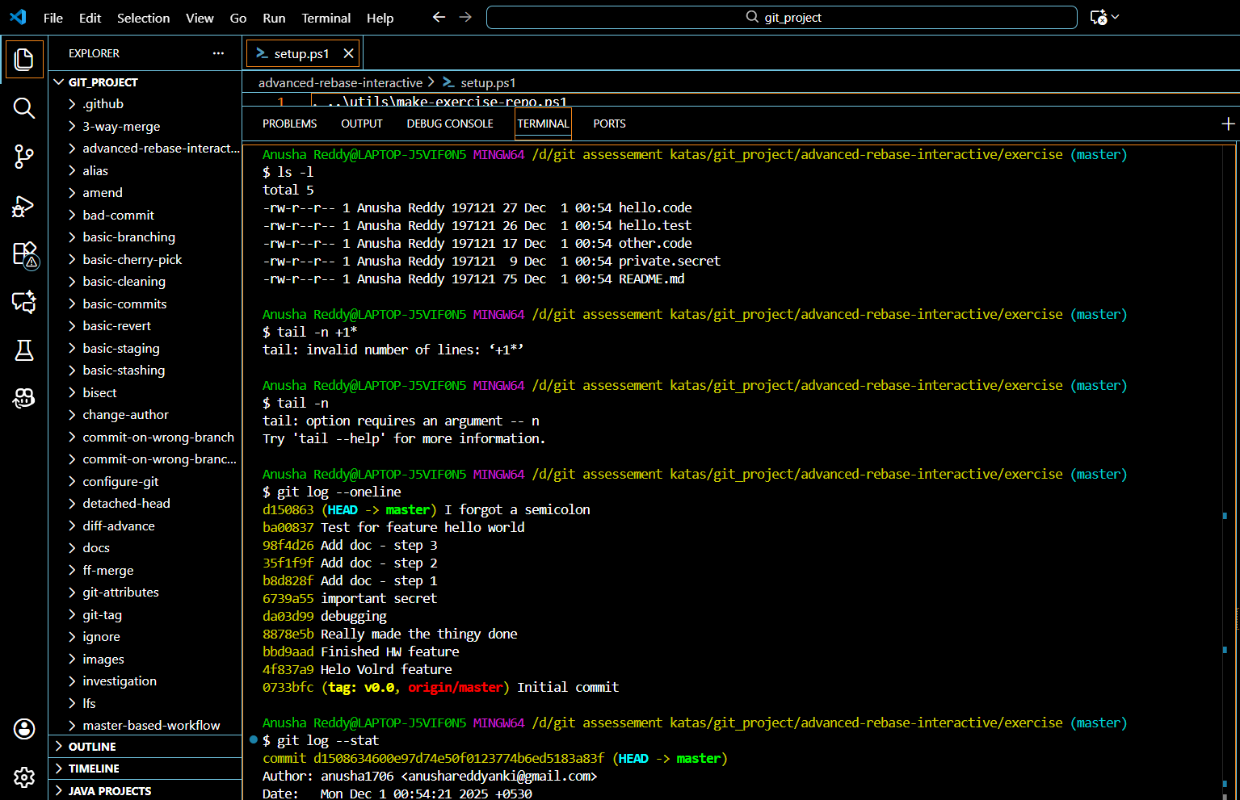

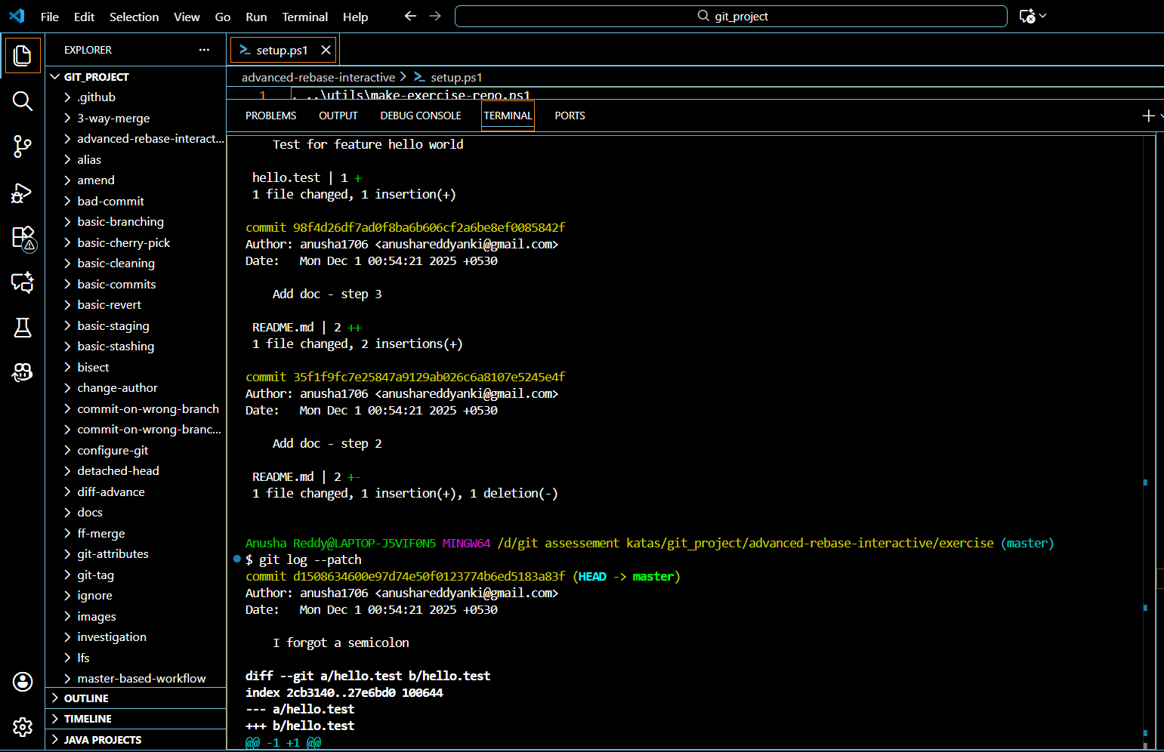

# **Basic stashing**

Setup :source setup.h

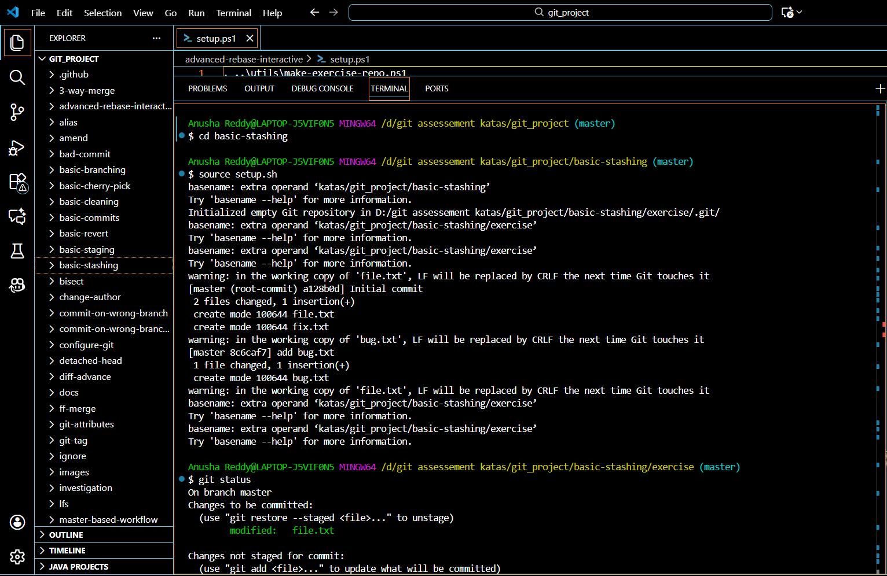

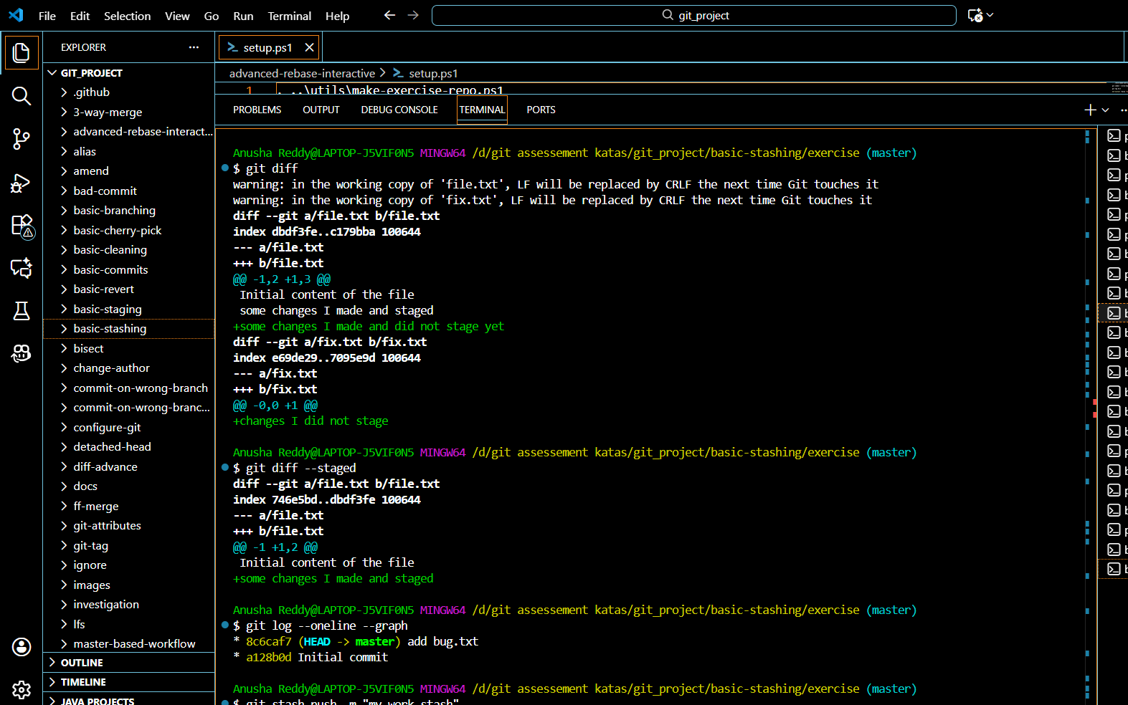

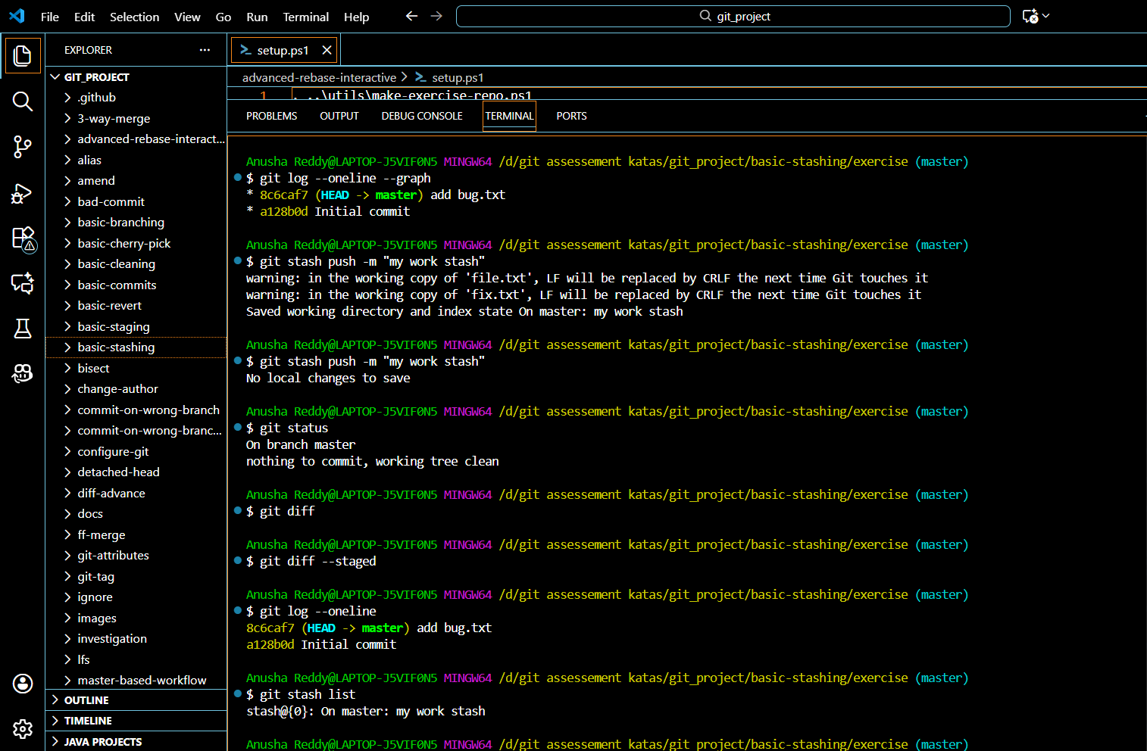

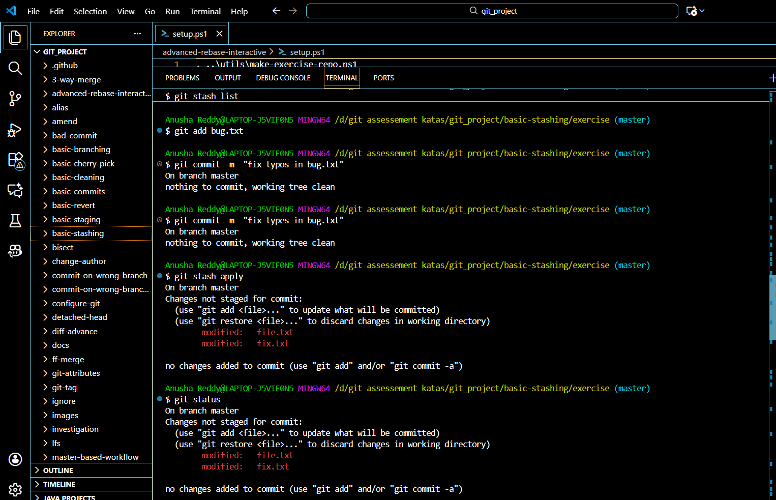

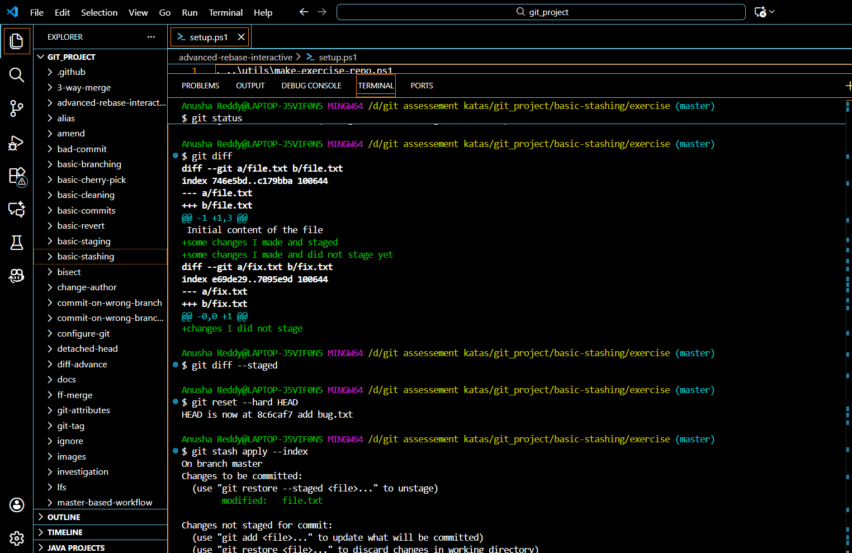

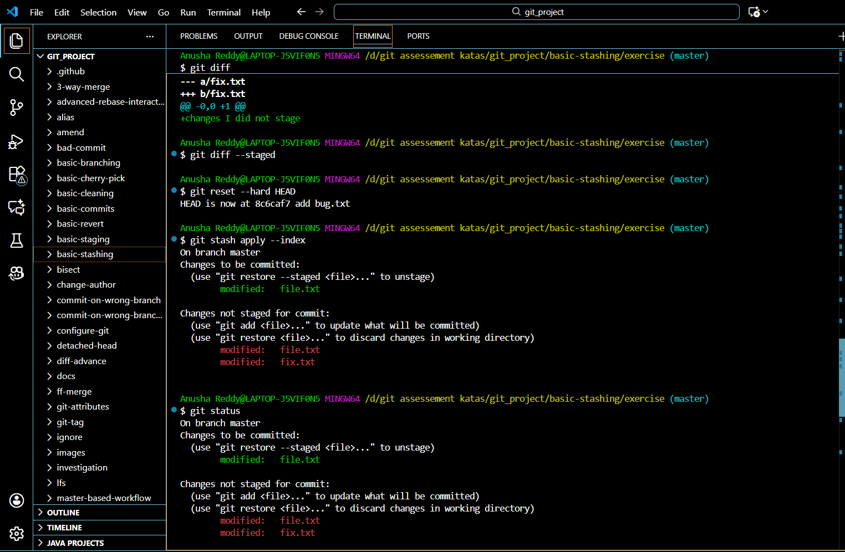

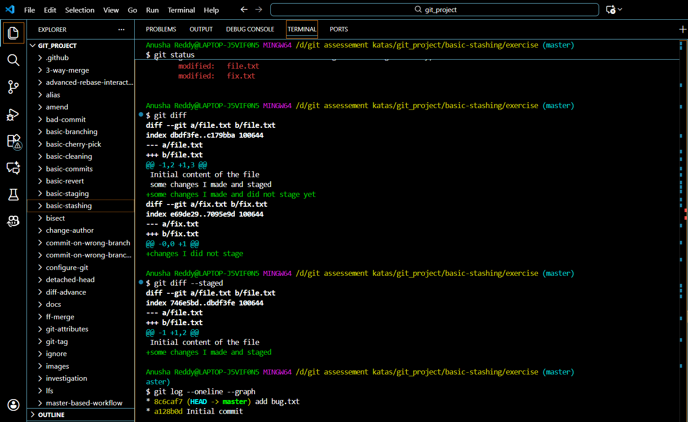

The commands for implementing:

git status

git diff

git diff --staged

git log --oneline --graph

git stash push -m "my work stash"

git log --oneline

git stash list

git stash apply

git status

git diff

git diff --staged

git reset --hard HEAD

git stash apply --index

git status

git diff

git diff --stage

git stash drop

git stash list

git log --oneline --graph

# **Basic Ignore**

SETUP :

Source [setup.sh](http://setup.sh)

Implementation

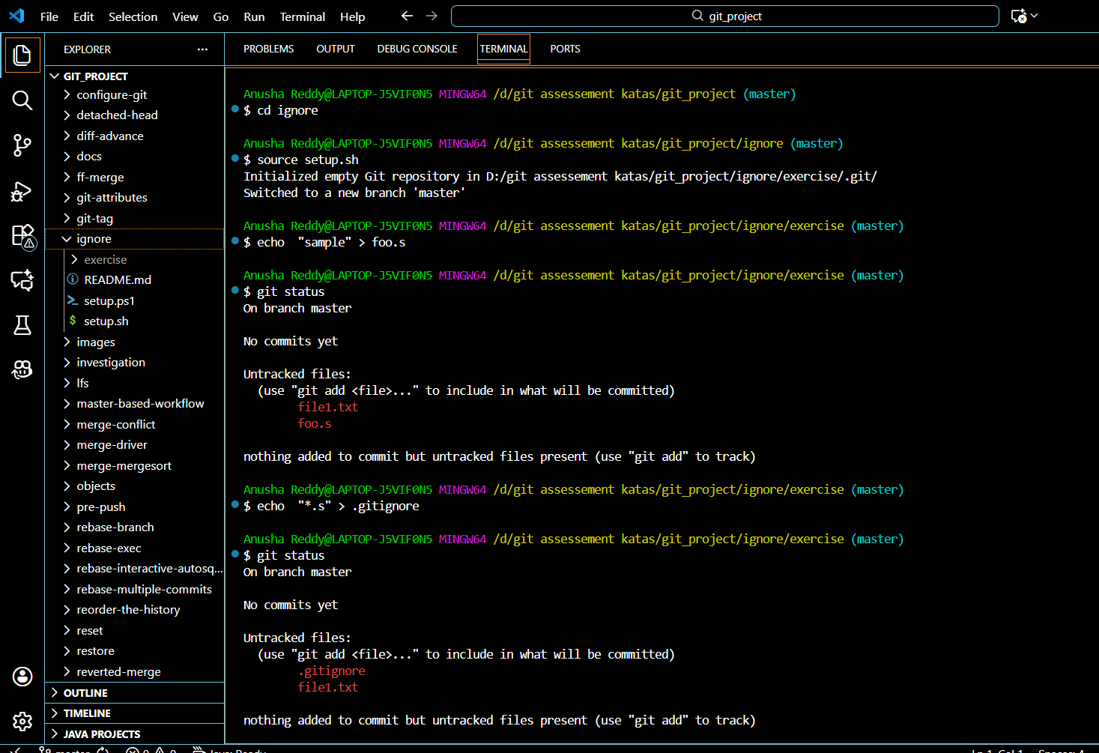

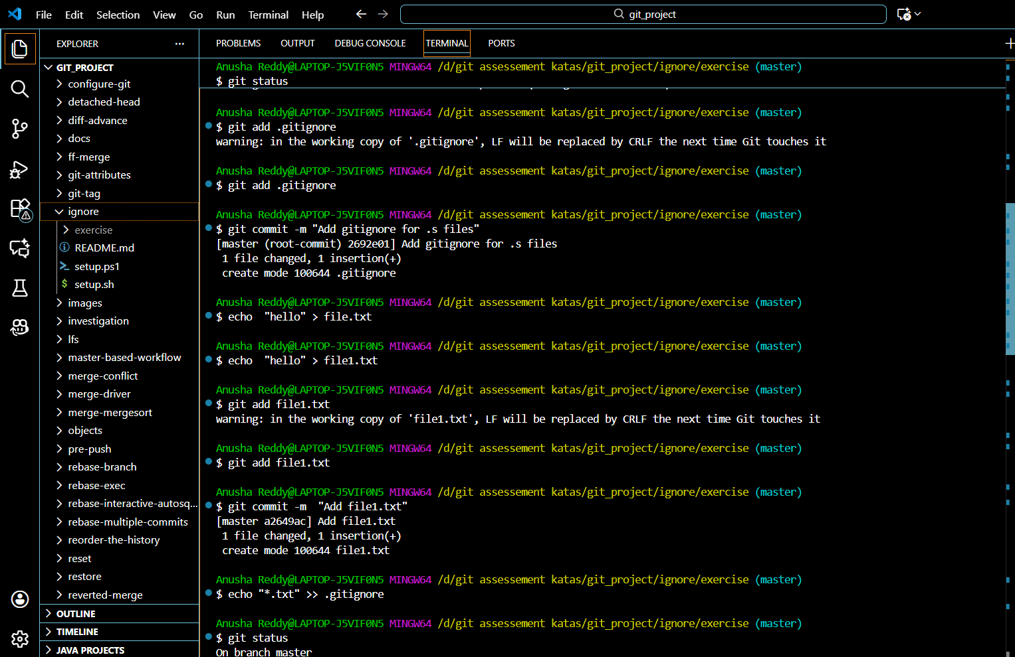

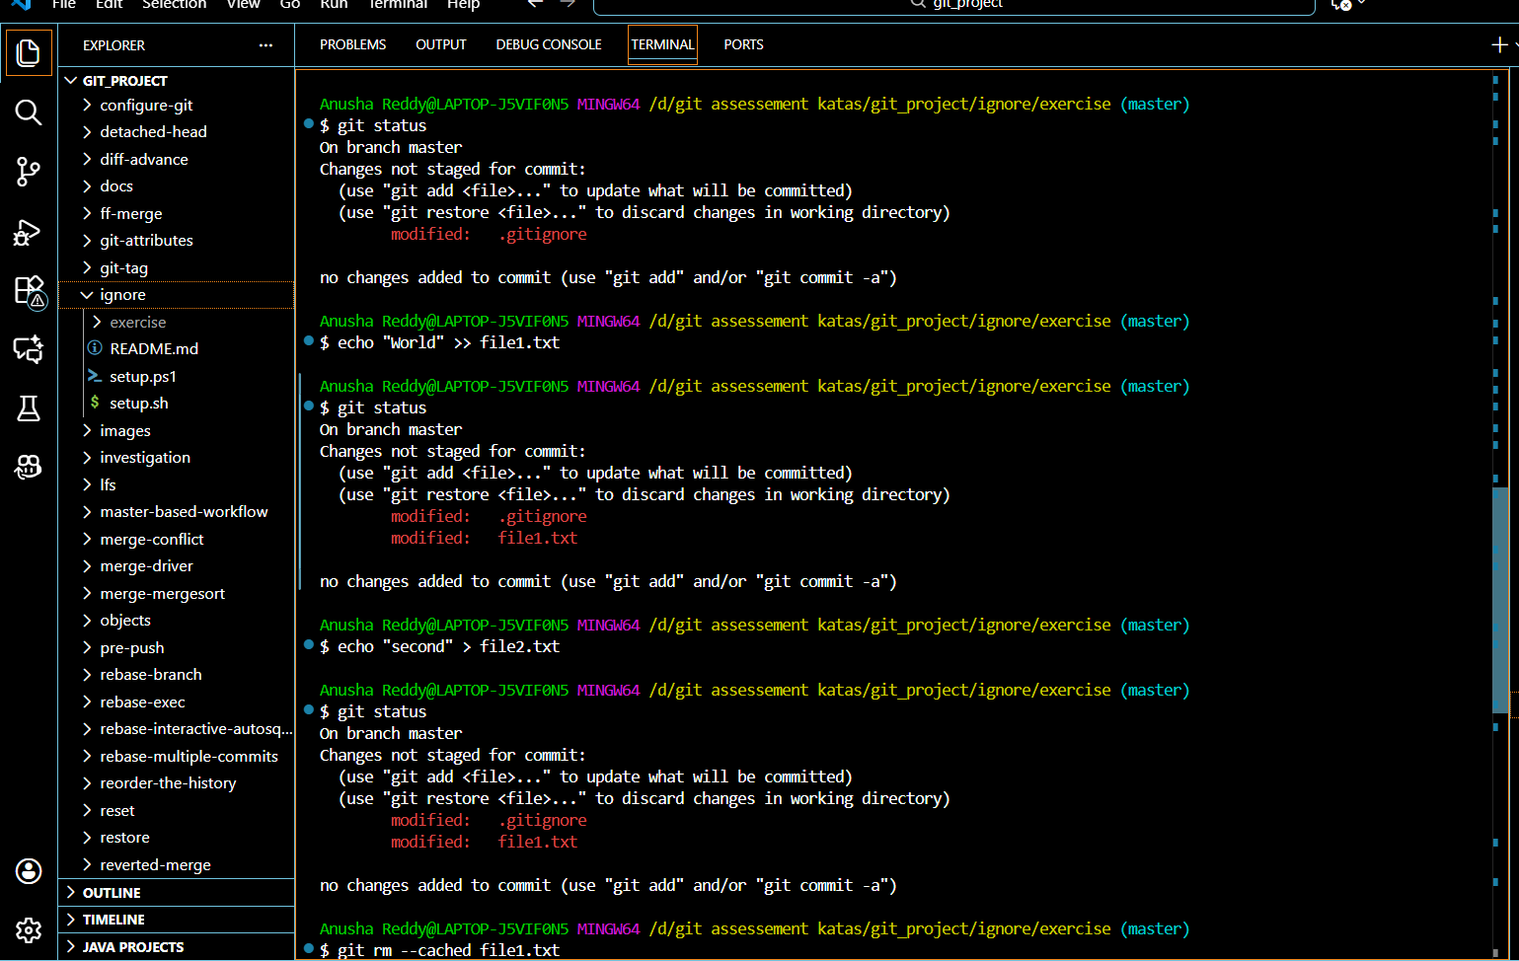

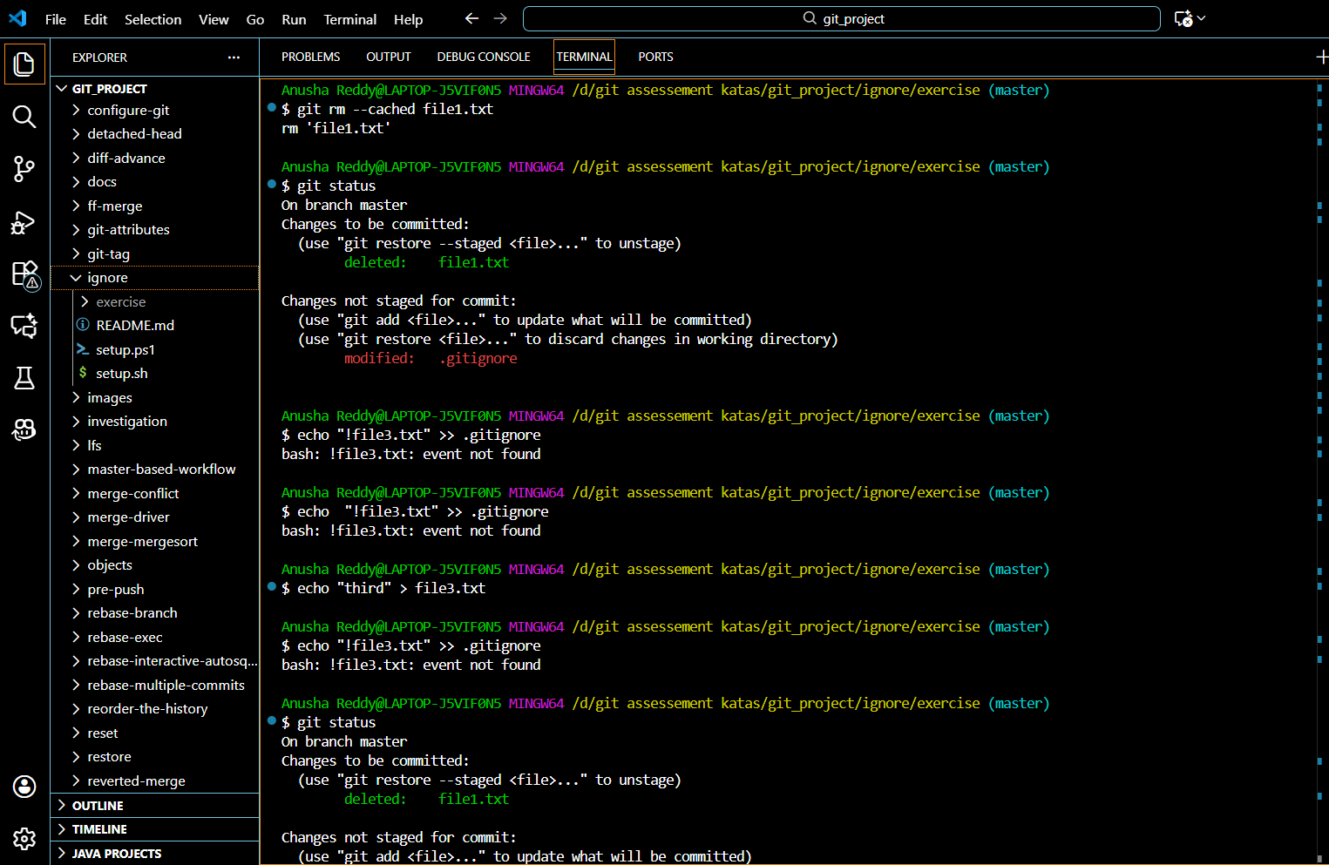

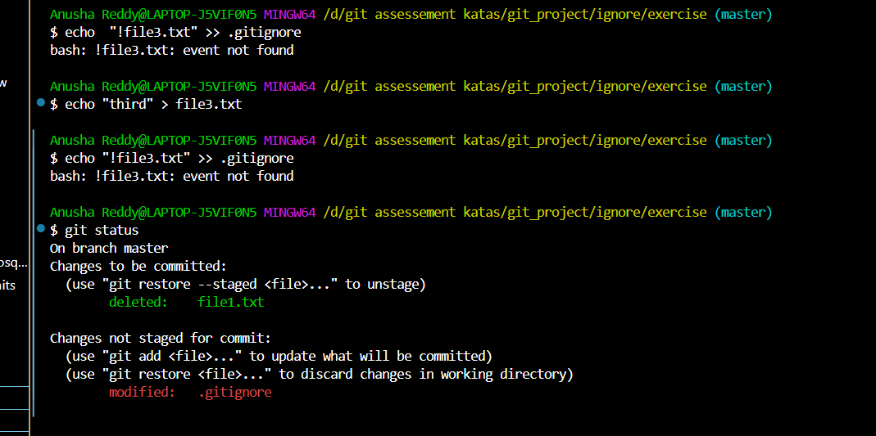

# **Submodules**

SETUP :source [setup.sh](http://setup.sh)

The Implementation

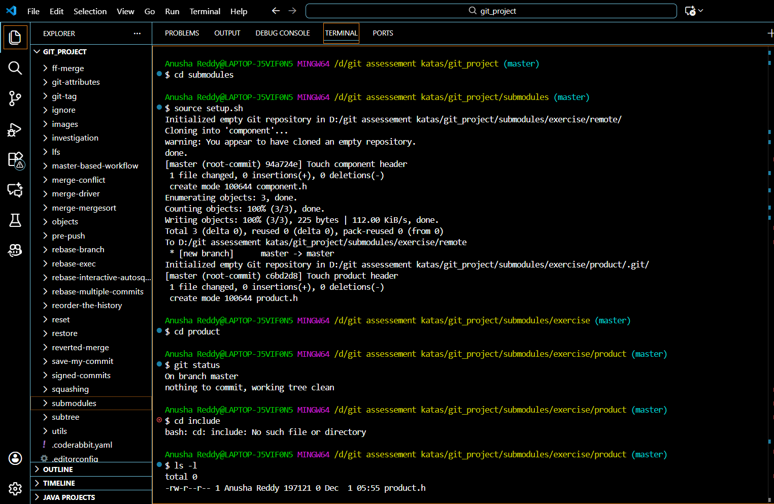

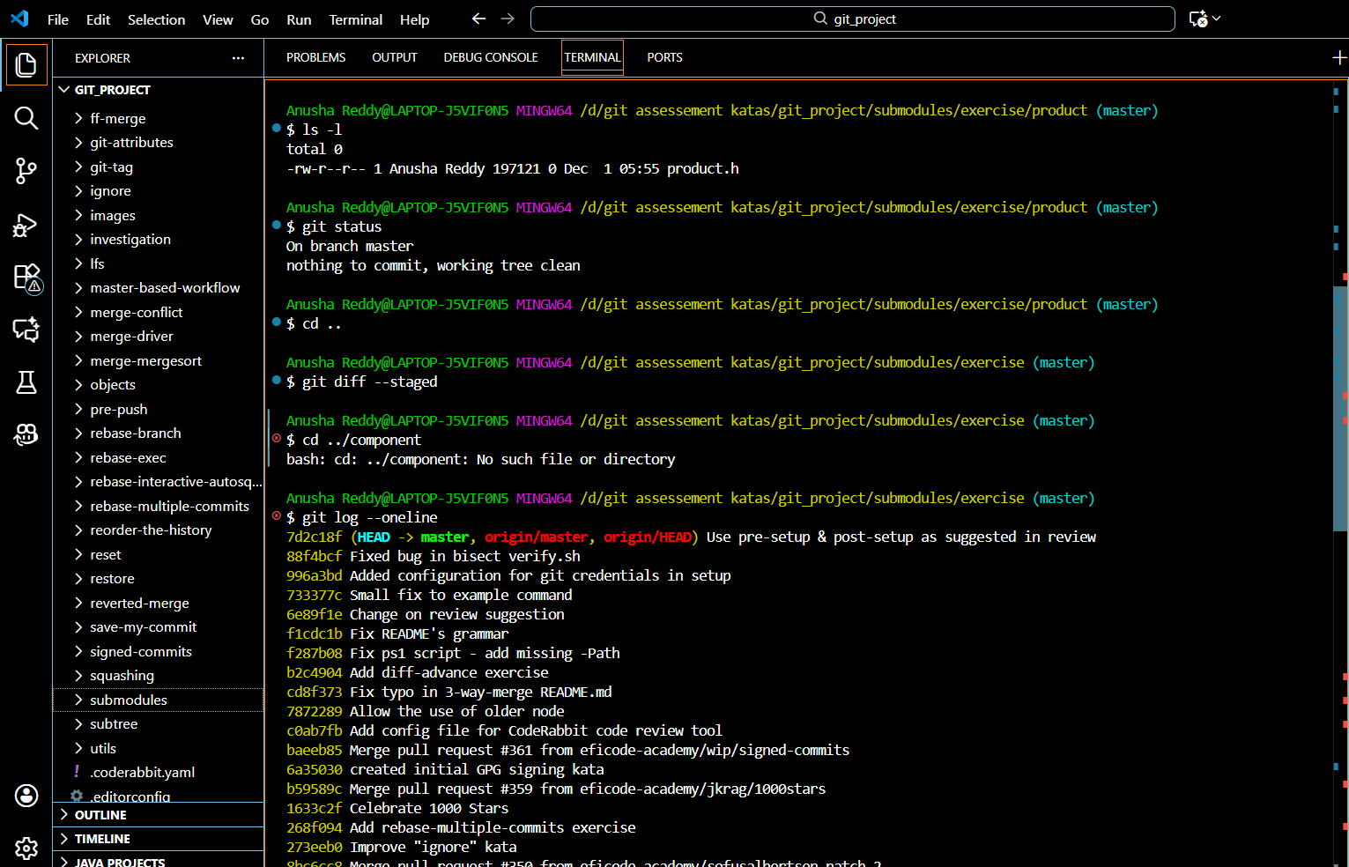

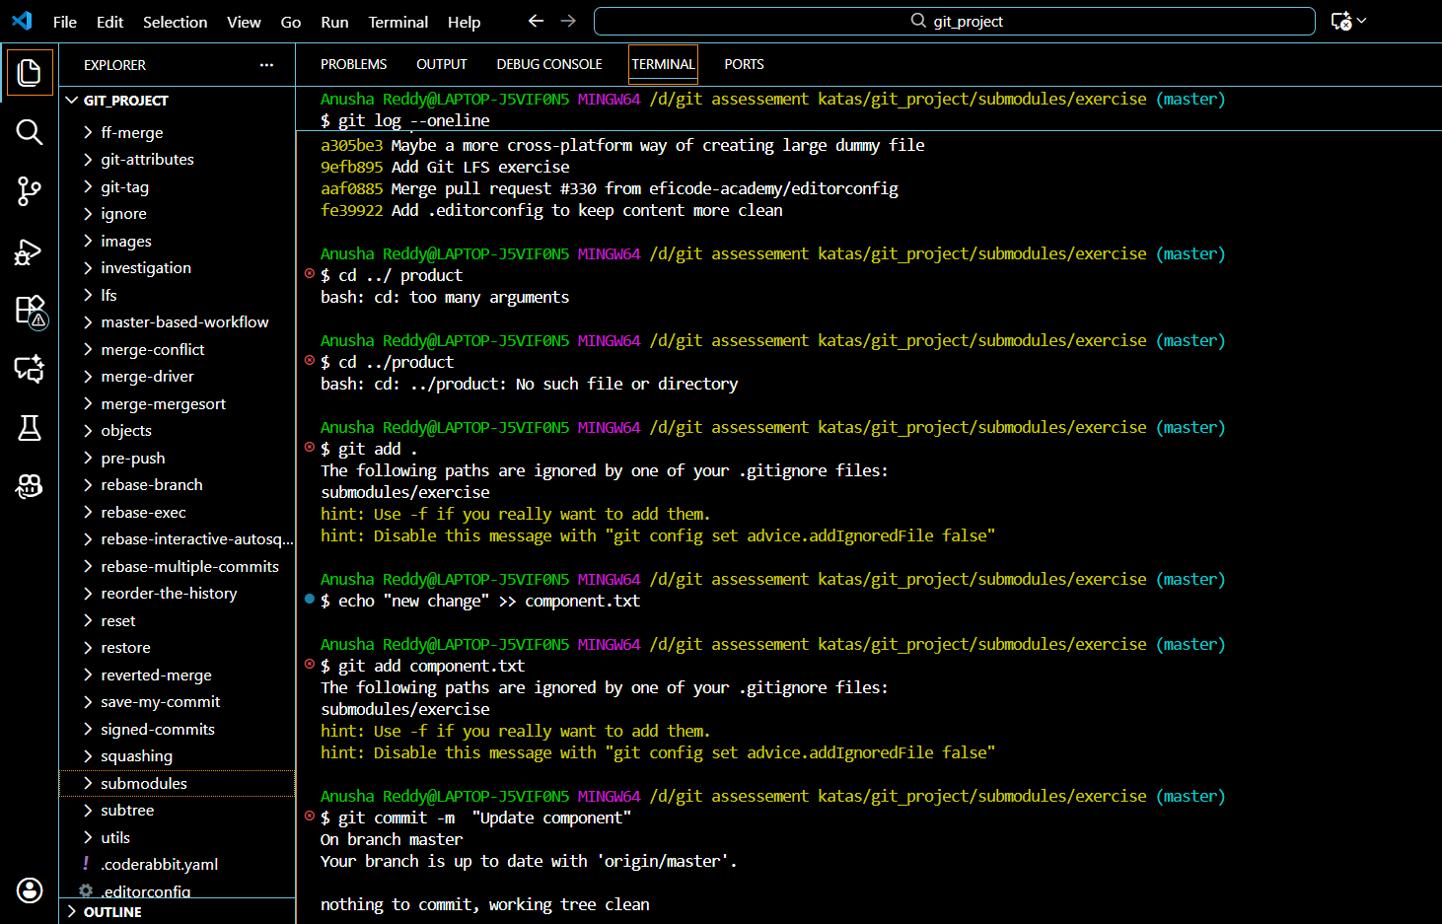

# **Tagging of the commits**

[Tags](https://git-scm.com/book/en/v2/Git-Basics-Tagging) are convenient for keeping track of commits that bump a version number. One way of using them is together with branches, where we can tag commits in a branch if they bump the version number, e.g., a branch called version/1.1 can have the tags 1.1.1, 1.1.2 etc. Tags can also be used without branches.

There are two types of tags, annotated tags and unannotated tags. Annotated tags can contain additional information, i.e., you could add some log output, in addition to the name. Apart from annotated tags, you can create unannotated tags that just have the name. In some cases, tags with no annotations work well, because the tag name and the changes of the commit contain the necessary information.

SETUP : source [setup.sh](http://setup.sh)

The implementation

